Group Project Documentation

1: Need Finding

**Exploratory stage**

**What is the story?**

Screen time of small children has raised significantly. There are various researches going on in

the present revealing the ill effects of increased screen time. Some researches reveal that there is

lag of speech or speech delay when the child is prone to excess screen time within 2 years of age.

One of the scientific researches reveals that the children are not able to correlate the 2-dimensional

structure that they view on screen with the real time 3-dimension things in the world, thus leading to

language confusion and speech delay. So, as a mom of a toddler I would like to have a solution to

regulate the screen time of young children.

**Alternatives**

Manual monitoring of how much time each child spends on digital devices everyday should be done

by parents and taken track of it.

**Possibilities**

* Is the child's screen time been monitored or taken for granted?
* Is the child really exposed to excess screen time?
* Can all parents be able to handle screen time management if there is an application created for it specifically?
* How screen time be taken care of in case of multiple kids at home?

What is already there?

Currently, there exists some applications to monitor screen time of children.

How your project will contribute?

Our project will ensure to target all parents and help them to monitor screen time of the children.

In addition to that, we are planning to add some features to block restricted sites and generate

weekly report of how much time the child spends on screen.

What is the uniqueness of your project?

We are planning to group 3 features (setting time, setting application and generating report)

together in a single application. Moreover we are planning to add some accessibility features like

‘Guidelines to handle the application’ in consideration of technically incompetent parents.

2: Stakeholders

* Direct Stakeholders :All parents who would like to have automatic control of children screen time.
* Indirect stakeholders : Children, All kids channel/application providers

3: Group Proposal

**Setting**

* Context
  + Environment

With rapid growth of technology, entertainment and learning of children these days are not only tied to books, dolls or toys anymore. Digital displays of devices such as television, computers, tablets,and smartphones are also playing important roles. The screen time children spend on these device has been controversial for years about its advantages in learning and its drawback with cognitive, language social and emotional delays due to less social interaction. Children should be allocated a proper amount of screen time separate from the time that they allow to play creatively, rest and interact with people in a pace which appropriate for their developmental stages.

Many busy parents are incapable of keep tracking of the screen time and even some do, it is not easy to seperate children from devices. Some children understand their parents point of limiting their screen time, but some are too young to understand or they deny to cooperate. Our team has come up with an idea that it would be very useful for parents and children if there is an application to help parents keep track of screen time and also control access to digital devices in order to save them from excessive use while they can also learn and enjoy the technology.

**Jane is a busy working mom. She works as a software developer along with doing her second degree in school. Her husband too works close to 70 hours a week. Jane has a 3 year old son and she wants to spend more time with him after his day care but most of the time she becomes too overwhelmed and does not have enough energy left to entertain or enjoy time with her child.**

**So Jane allows her son to use digital devices to keep him occupied. The child gets to spend about 4-5 hours a day watching youtube and playing games in ipad. Few days back, Jane started to see her son having some problem while socializing with other children. In addition to that, his school teacher noticed that the child has very short period of concentration when he did activities in class. So thinking of all these factors, Jane started to keep an eye on her child's screen time. Jane tries to restrict the screen time and keep his ipad away but sometimes he threw a tantrum or even sneak in to grab his ipad back. Jane feels helpless and she needs something to help her keep track and control screen time for her son. Jane finally thinks that she needs to restrict her son from excessive use of digital screen devices.**

* People involved

The application our team proposes to develop involves initial users including children, parents or guardians and other family members with possibility to expand to schools, educational organizations and daycare businesses. This mean the design needs to be able to serve people in wide range of age and easy enough for children to understand.

* Task being accomplished

Help parents manage and control screen time of children

**Sequence**

* What leads someone to use the app?

Users will be lead to use this app if they desire regulated automated control over their dependents electronic devices. The user would be able to monitor and schedule the use of electronic devices.

* Steps to take from setting to desired outcome

To get the desired outcome, the user would:

1. Download the app
2. Open the app
3. Choose the device or devices to schedule
4. Create the schedule
5. Set limitations within schedule
6. Set the rotation of schedules
7. Allow the User to edit as they please
8. See the summary of screen time

* Illustration of a task

When the user decides to use our app. They must first download the app and open the app. There they will have to decide which device to set their desired schedule from. The User creates the schedule for the desire device. Within the schedule, the user will be able to set the limitations on the recipient, or the dependent, of the schedule. The user will then set the rotation of schedules, so schedules can differ by day. By default, a single schedule will be on a one day, or a daily, cycle. After the app is used, the schedule would be invoked, and the dependent will be . If the user desires to edit the schedule, they can select the schedule and create, edit , or delete as they please.

**Satisfaction**

* What motivates the use of the solution?
  + Technology, especially ones on-the go such as phones and laptops, give children the ability to hide in their room and spend endless hours on the device to keep themselves entertained. With limited time, however, kids will seek other company leading to **more in-person interactions**, whether it be with friends or family members.
  + An issue that parents may not be aware of is the content their kids are exposed to when mindlessly exploring digital devices. Uncensored websites, for example, may have ads or pop-ups that contain graphic pictures or videos of traumatic events. This can bring on anxiety to kids while the parents are none the wiser. The goal is with less screen time, there will be **less stress** put on the individual.
  + These days, children has a short attention span when it comes to less desirable activities due to long periods of entertainment and “fun” they find on a digital device. Limiting time on it can **improve social and interpersonal skills**.
  + Too much time online can cause children to forget how to interpret and show emotions. When involving the world wide web, which is arguably a platform that contains many users that are desensitized, children don’t stand a chance at performing proper, kind interactions with other people. Less screen time would help children **learn acceptable face-to-face communication**.
* What need it fulfills?
  + This app is made more for the parents and their concern for their kids’ well-being as they grow up. Parents have a need to see their children become the best versions of themselves, and based on plenty of user experiences, technology and everything it embodies has the ability of diminishing a person’s social and mental stability. To summarize the above, these are some needs a parent hopes to fulfill:
    - More in-person interactions
    - Less stress and anxiety
    - Improve social and interpersonal skills
    - Learn acceptable face-to-face communication
* What does it enable users to accomplish it?
  + Users will be able to control how long their children can use a digital device and at the same time improve their lifestyle. The users will also be able to analyze how much the kids are using certain technology on average per week or per month. Monitoring this gives the users an idea on what to improve.

**Social Impact**

* **Identify specific benefits**

1. Helps parents to restrict kids especially toddlers` screen time and encourages the children to engage in interactive social activities rather than sticking their mind with the 2-dimensional cartoons that they watch on gadgets.
2. Scientific researches reveal that excess screen time to children below one year of age has been one of the crucial causes for speech delay in children. So, restriction of screen time will enable children to grow healthier mentally and physically.

* **Address security and privacy issues**

1.There are no privacy issues as no data will be transmitted to the server. All data relevant to the application will be stored locally.

2. Login details are to be maintained for the application.

* **Discuss accountability and responsibility for system misuse and failure**

1. Apart from children knowing the password of the application, the system cannot be misused by any other means.
2. Failure of the system would require parents/caretaker to manually monitor the number of hours that a child spends watching TV/mobile.

* **Promote simplicity and preserve what works**

The system is just like a child lock system wherein it helps to solve parents` worry about the children excess screen time by means of a simple application that monitors the children screen time and sets timer to lock the gadget once the time limit that is specified is exceeded.

* **Weigh individual rights vs. societal benefits**

The application will be beneficial to any system where screen time norms for children are to be implemented. Be it educational or entertainment, the screen time regulation for children is a must for this technological world. So, the application will benefit parents, daycare and schools keeping children well-being into consideration.

* **Assess trade-offs between centralization and decentralization (if applicable)**
* **Ensure diverse access**

The application is designed for the issue that all children around the world are subjected to. So a diverse implementation/access is a mandatory requirement to be ensured.

4: Matrices

1. User behavioral patterns, and attributes as opposites

* Technically competent <-> novice moms
* Younger kids <-> Older kids.
* Working moms <-> Stay at home moms
* Lenient <-> Strict moms in regulating screen time of children.

1. Key questions

* How will the user needs be tackled in using the application?
* How will the user satisfaction be in using the application?

1. Creation of matrices

We tried to merge the cell content of all our individual matrices to our group matrices. And,

specifically analysed on how the application will satisfy technically incompetent people.

|  |  |  |  |  |
| --- | --- | --- | --- | --- |
| ***How will the user needs be tackled in using the application?*** | | | | |
| **Technically competent moms** | Allows managing kids` screen time without any manual intervention. |  |  | Various features in the application will allow them to block certain website.    Allows them to implement the system in various devices. |
|  |  |  |  |  |
| **Technically no-vice moms** | Easy screen user-friendly screen tracker system allows handling of screen time management of kids with ease.    Frequent notifications ease the use of the application.    Provides limited choice to select the menu accordingly. |  |  | Allows the moms to enforce certain rules in regards with the screen time by automatically blocking specific sites.    Enables the moms to learn various features as per the additional guidelines provided. |
|  | **Younger kids Older kids** | | | |

|  |  |  |  |  |
| --- | --- | --- | --- | --- |
| ***How will the user satisfaction be in using the application?*** | | | | |
| **Working moms** | Being lenient working mom can allow kids to be attached to screen always. This application restricts such leniency.    Automatically locks out when specific screen time is completed.    Takes care of kids` mental health by restricted screen time even when mom is working remotely. |  |  | Allows remote access of kids` screen time details even when mom is working, thus implementing strict screen time regulation.    Screen tracker report can be downloaded anytime even when mom is working remotely. Helps in improvising n regulating screen time activity of children. |
|  |  |  |  |  |
| **Stay at home moms** | Allows to implement some strict regulations regarding screen time activities of kids.    Promotes mental health of kids by restricted screen time activity. |  |  | Relieves moms from manual monitoring of screen time management works at home by automatically locking out after the set time limit.  Screen tracker reports will provide moms an idea on areas to improvise regarding screen time limitation. |
|  | **Lenient Strict** | | | |

1. i) Common factors on the matrices

* Allowing all parents, be it stay at home parent/ working parents to manage kids` screen time without any manual intervention.
* Allows the moms to enforce certain rules in regards with the screen time by automatically blocking specific sites and by setting certain time limit.

ii) User groups (personas)

* All parents/caretakers who have children and would like to have automatic control over children screen time.

iii) Facts

* Application will ease parental control over screen time management activities of children by automatically locking out the device after the specified time limit.
* Both working and stay at home moms are mainly focused for the benefit of the application.
* Ease of application -- > can change the settings according to the user needs (edit time settings).

iv) Assumptions to research

* Guidelines/tutorial will be used by technically no-vice moms.
* Remote tracking system will be used by working moms.
* Frequent notifications will help parents to easily use the application.
* Will help in promoting mental health of kids by regulated screen time and can reduce the ill-effects of excess screen time in children.

**e . Scenario**:

As a parent, I want to implement certain parental controls on my children screen time, so that their screen time is under control.

5: Personas

Persona creating process (Merging of all individual personas):

We wanted the group persona to focus on the following points,

* A busy mom either be it a stay at home or a working mom, we wanted to create a scenario that the parent is very busy. Thus the kid is exposed to excess screen time. All our individual personas talked about a busy mom by creating some scenario. So we tried to merge all our individual persona to portray such busy scenario.
* Next we wanted to include some inaccessible issues for the user so that we design our prototype to sort out the accessibility issues. So we merged the inaccessible features mentioned in individual persona into our group persona, thus made it to be technically incompetent along with having low vision issues.
* All our individual personas had a scenario where the parent urges to have some automatic control over kids` screen time. So we recreated the same scenario such that there is a need for the parent to have automatic control over children screen time.

So here is how the group persona merged to be:

Sheela, a stay at home mom has two children Alex and Dave, older and younger respectively. Alex goes to school while Dave is a toddler staying at home. Being a stay at home mom, she is always busy with her household chore routines along with child care activities. Right from her childhood, Sheela has vision related issues and to be specific she is short-sighted. Besides that, she feels that she is technically incompetent, or she is not up to the standards of the younger generation in technical aspects. Personally, she is very lenient towards her children in implementing any rules and regulations at home.   
  
Dave is a year old, very active kid and just started to babble some baby words. Sheela is frustrated with chores all the time, and not able to keep Dave occupied all the time. Because of these reasons, Dave gets to watch cartoons for more than 3 hours a day if left unmonitored with regards to screen time. Even Alex gets to spend about an hour on TV after he returns from school. Hearing about recent scientific researches about how excess screen time affects kids` mental development, Sheela is worried about how excess screen time in long run might influence her kids` social behavior and speech issues especially in case of Dave as he has just started to talk. Also, she wants to implement some stringent rules for Alex with regards to screen time. As Sheela is engaged in all other activities, she feels difficult to manually monitor how much time each kid spends on screen, and at the same time she is worried that excess screen time will mentally impact them in future. She feels that it would be better if kids spend an hour a day on these devices, and wishes to have some guidance on how to control the screen time activities of her children.

6: Group Feedback on Matrices, Persona and Scenarios

Matrices:

During group discussion, we found the the group matrices facts and assumptions were out of cell content of the matrices. So we edited them accordingly as follows:

**Known facts:**

* Allows to implement some strict regulations regarding screen time activities of kids.
* Application will ease parental control over screen time management activities of children by automatically locking out the device after the specified time limit.

**Assumptions:**

* Screen tracker reports will provide moms an idea on areas to improvise regarding screen time limitation.
* Promotes mental health of kids by restricted screen time activity.
* Enables the technically incompetent moms to learn various features as per the additional guidelines provided.
* Remote tracking system will be used by working moms.
* Frequent notifications will help parents to easily use the application.

Persona:

During group discussion, we were analyzing the group persona where we found that the persona was such that it did not show up having any accessibility issues. So we remodeled the persona as having low-vision issues along with technical incompetency.

Scenarios:

We created a scenario of a busy parent liking to have automatic control over screen time. So the group decided to create a scenario of a parent having multiple kids such that she does not have enough time to keep them occupied, thus ending up in giving the digital devices. Yet, worrying about their mental/physical well being due to excess screen time. The urge to implement some automatic control over children screen time leads her to explore the applications that are currently available in the market for this purpose.

**As a parent having two kids, I would like to implement certain parental control over my children screen time, so that they are not exposed to excess screen time.**

7: Storyboard Alternative

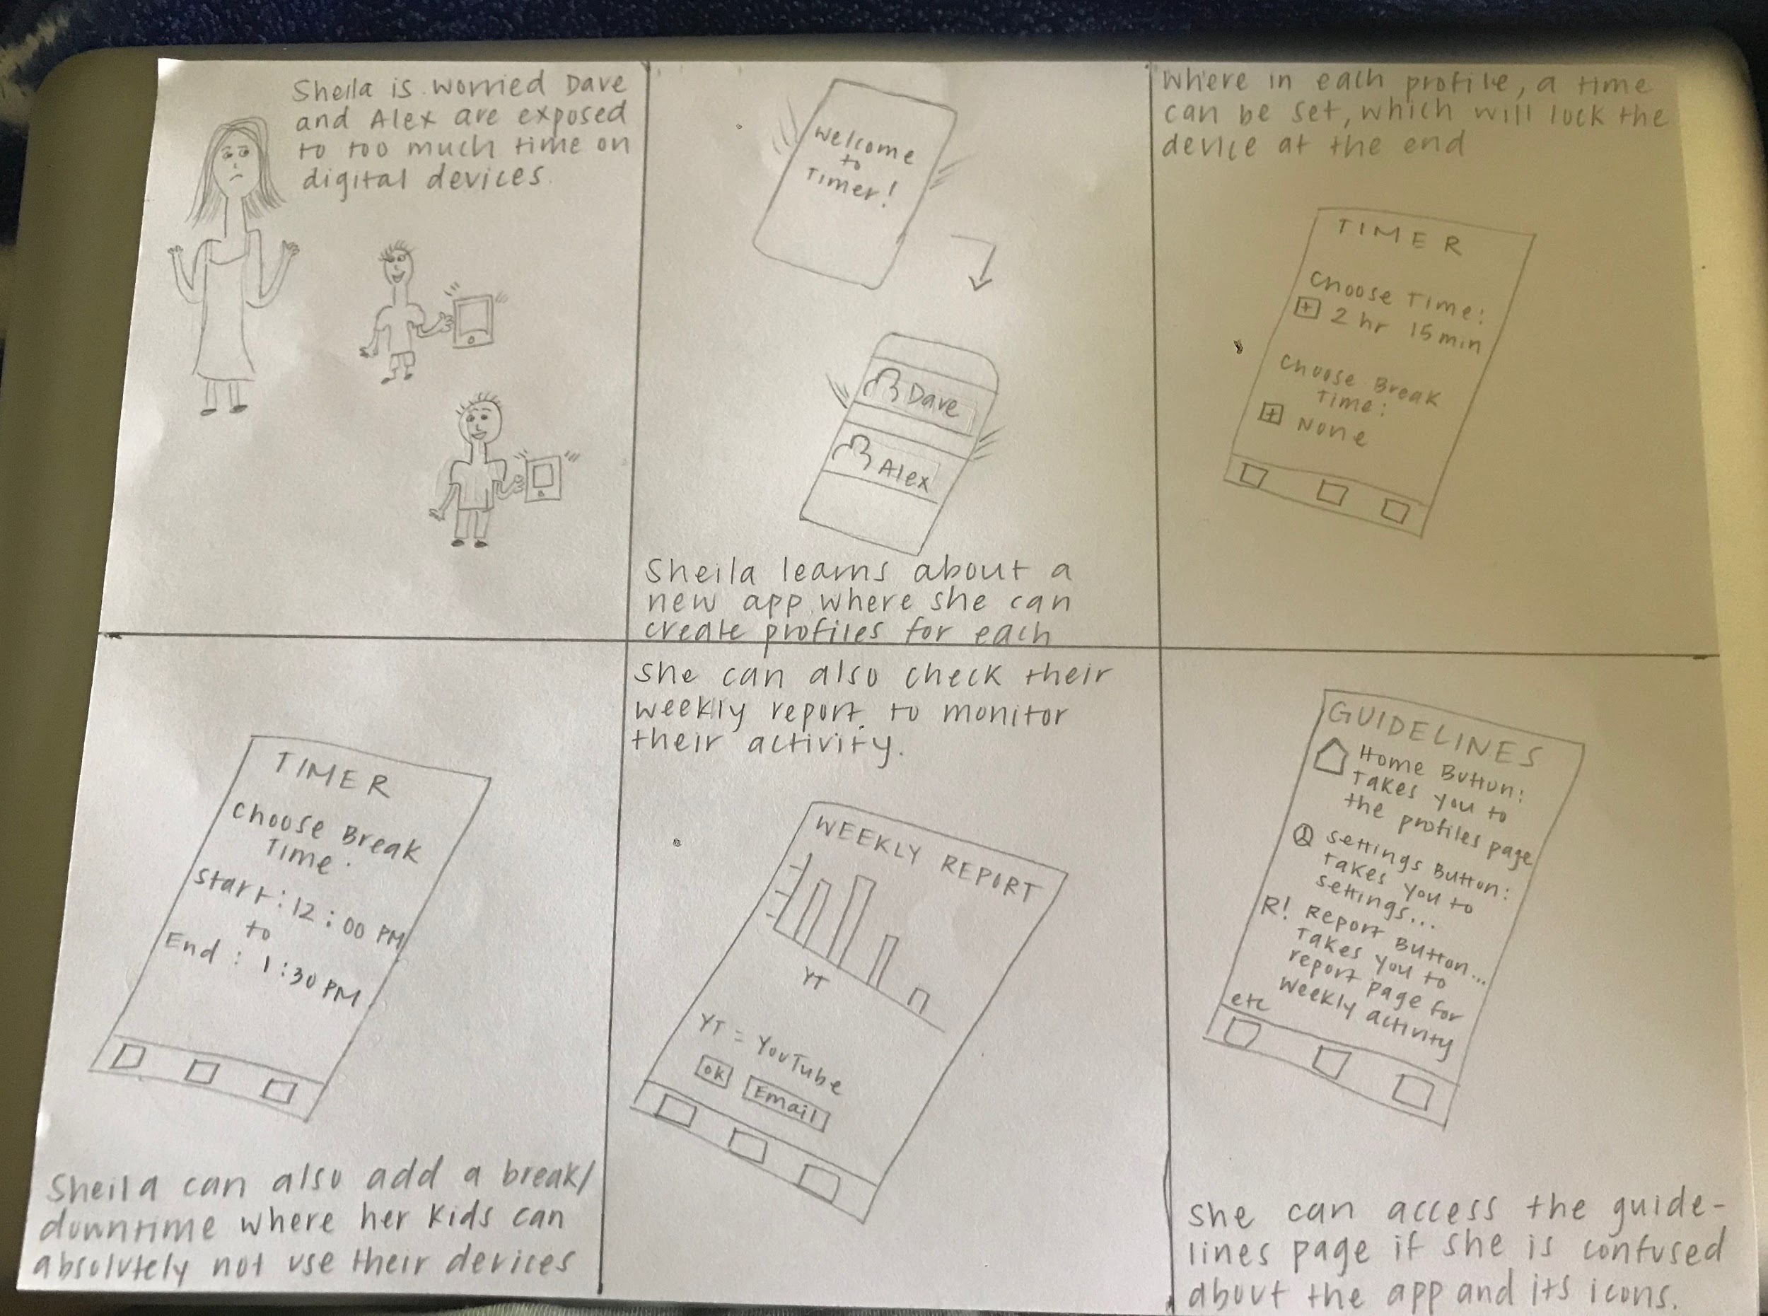

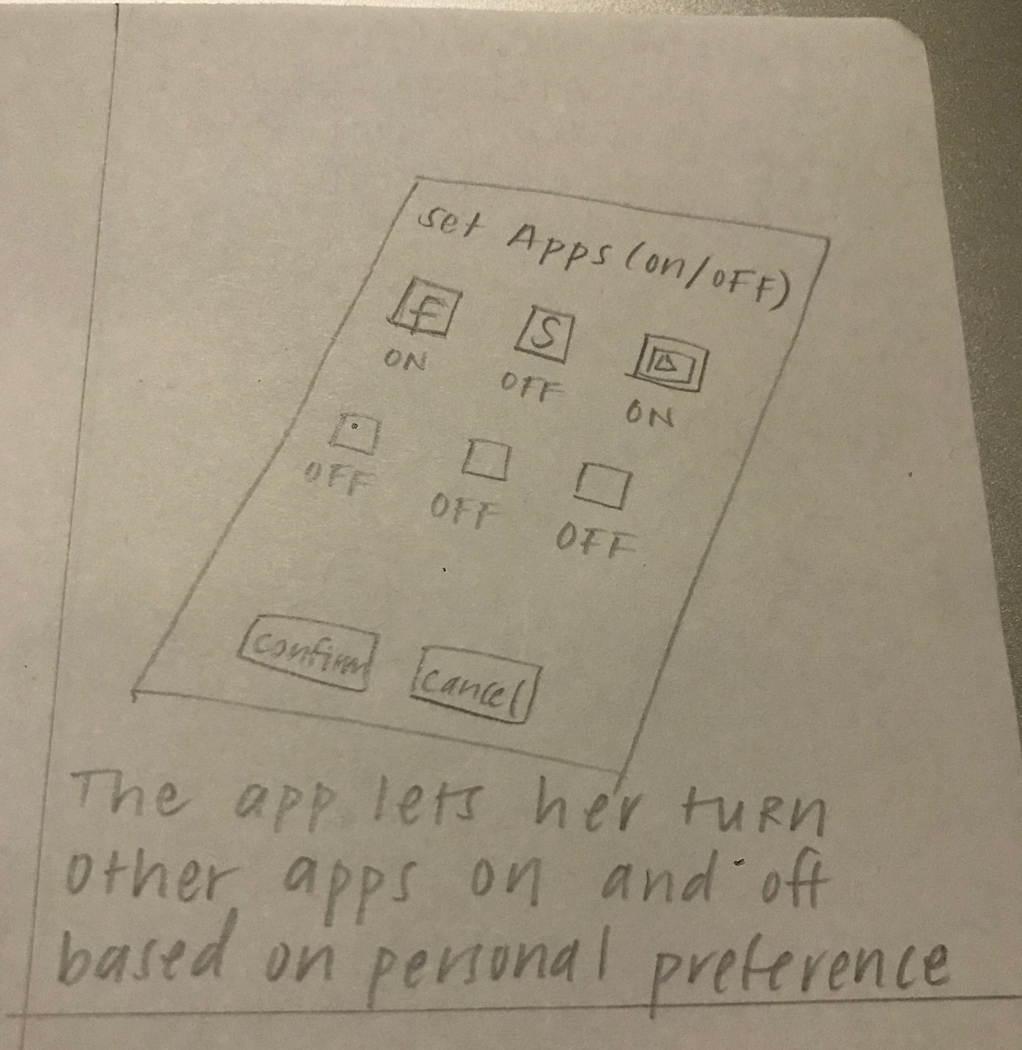

Sheela and her two sons are characters we would be using for our video prototype (next week’s assignment), but they are also included in the storyboard.

It starts with a worried Sheela, essentially, a **worried parent** who thinks about the amount of time their children spend on digital devices. ⇒ In the next box, Sheela learns about a new application that just might be able to help with her issue. The **issue is too much time on the screens**. It already starts out helpful; this app allows the **creation of profiles** for each child keeping things separate. ⇒ In the box after that, there is the main task of the application: **setting a time** that the kids are allowed to spend on their devices that will automatically lock the screen once the timer has reached 0. ⇒ The following box depicts another task: the ability to **add a break time** that a child under no circumstance is able to access their device. For example, they may not go on a tablet from 12PM to 1:30PM as this is the allotted time for lunch. ⇒ There will also be a feature that allows the parent to **set apps** based on their personal preference. For example, they can choose to keep YouTube on and Skype off. ⇒ There is also another useful task of being able to **check the progress and activity** of each child via the weekly report. This has a neat feature of sending an email to the parent if they wish to keep the data. ⇒ There is also a **“Guidelines” page** that will help the parent, for those who are less tech-savvy, understand the app and icons better. There will be additional features on the app that will help users who don’t know how to navigate the application.

8: Video Prototype

<https://drive.google.com/drive/folders/1HK_jD2Y9cczcFlhd9Xg3ddtG2LIM8jvi?usp=sharing>

9: Low Fidelity Prototype

Cell’s content and scenarios provide priority of features to support the main tasks of our application. In these tables below will demonstrate how each cell in matrices become a feature in the application

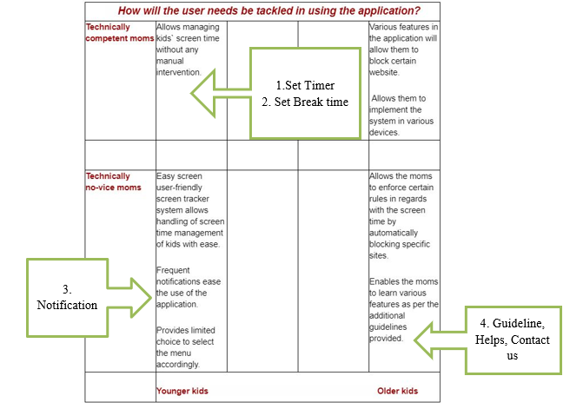

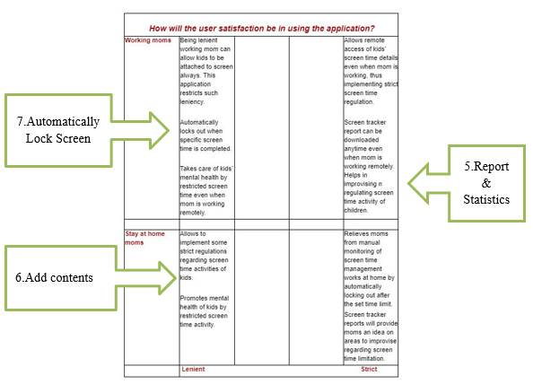

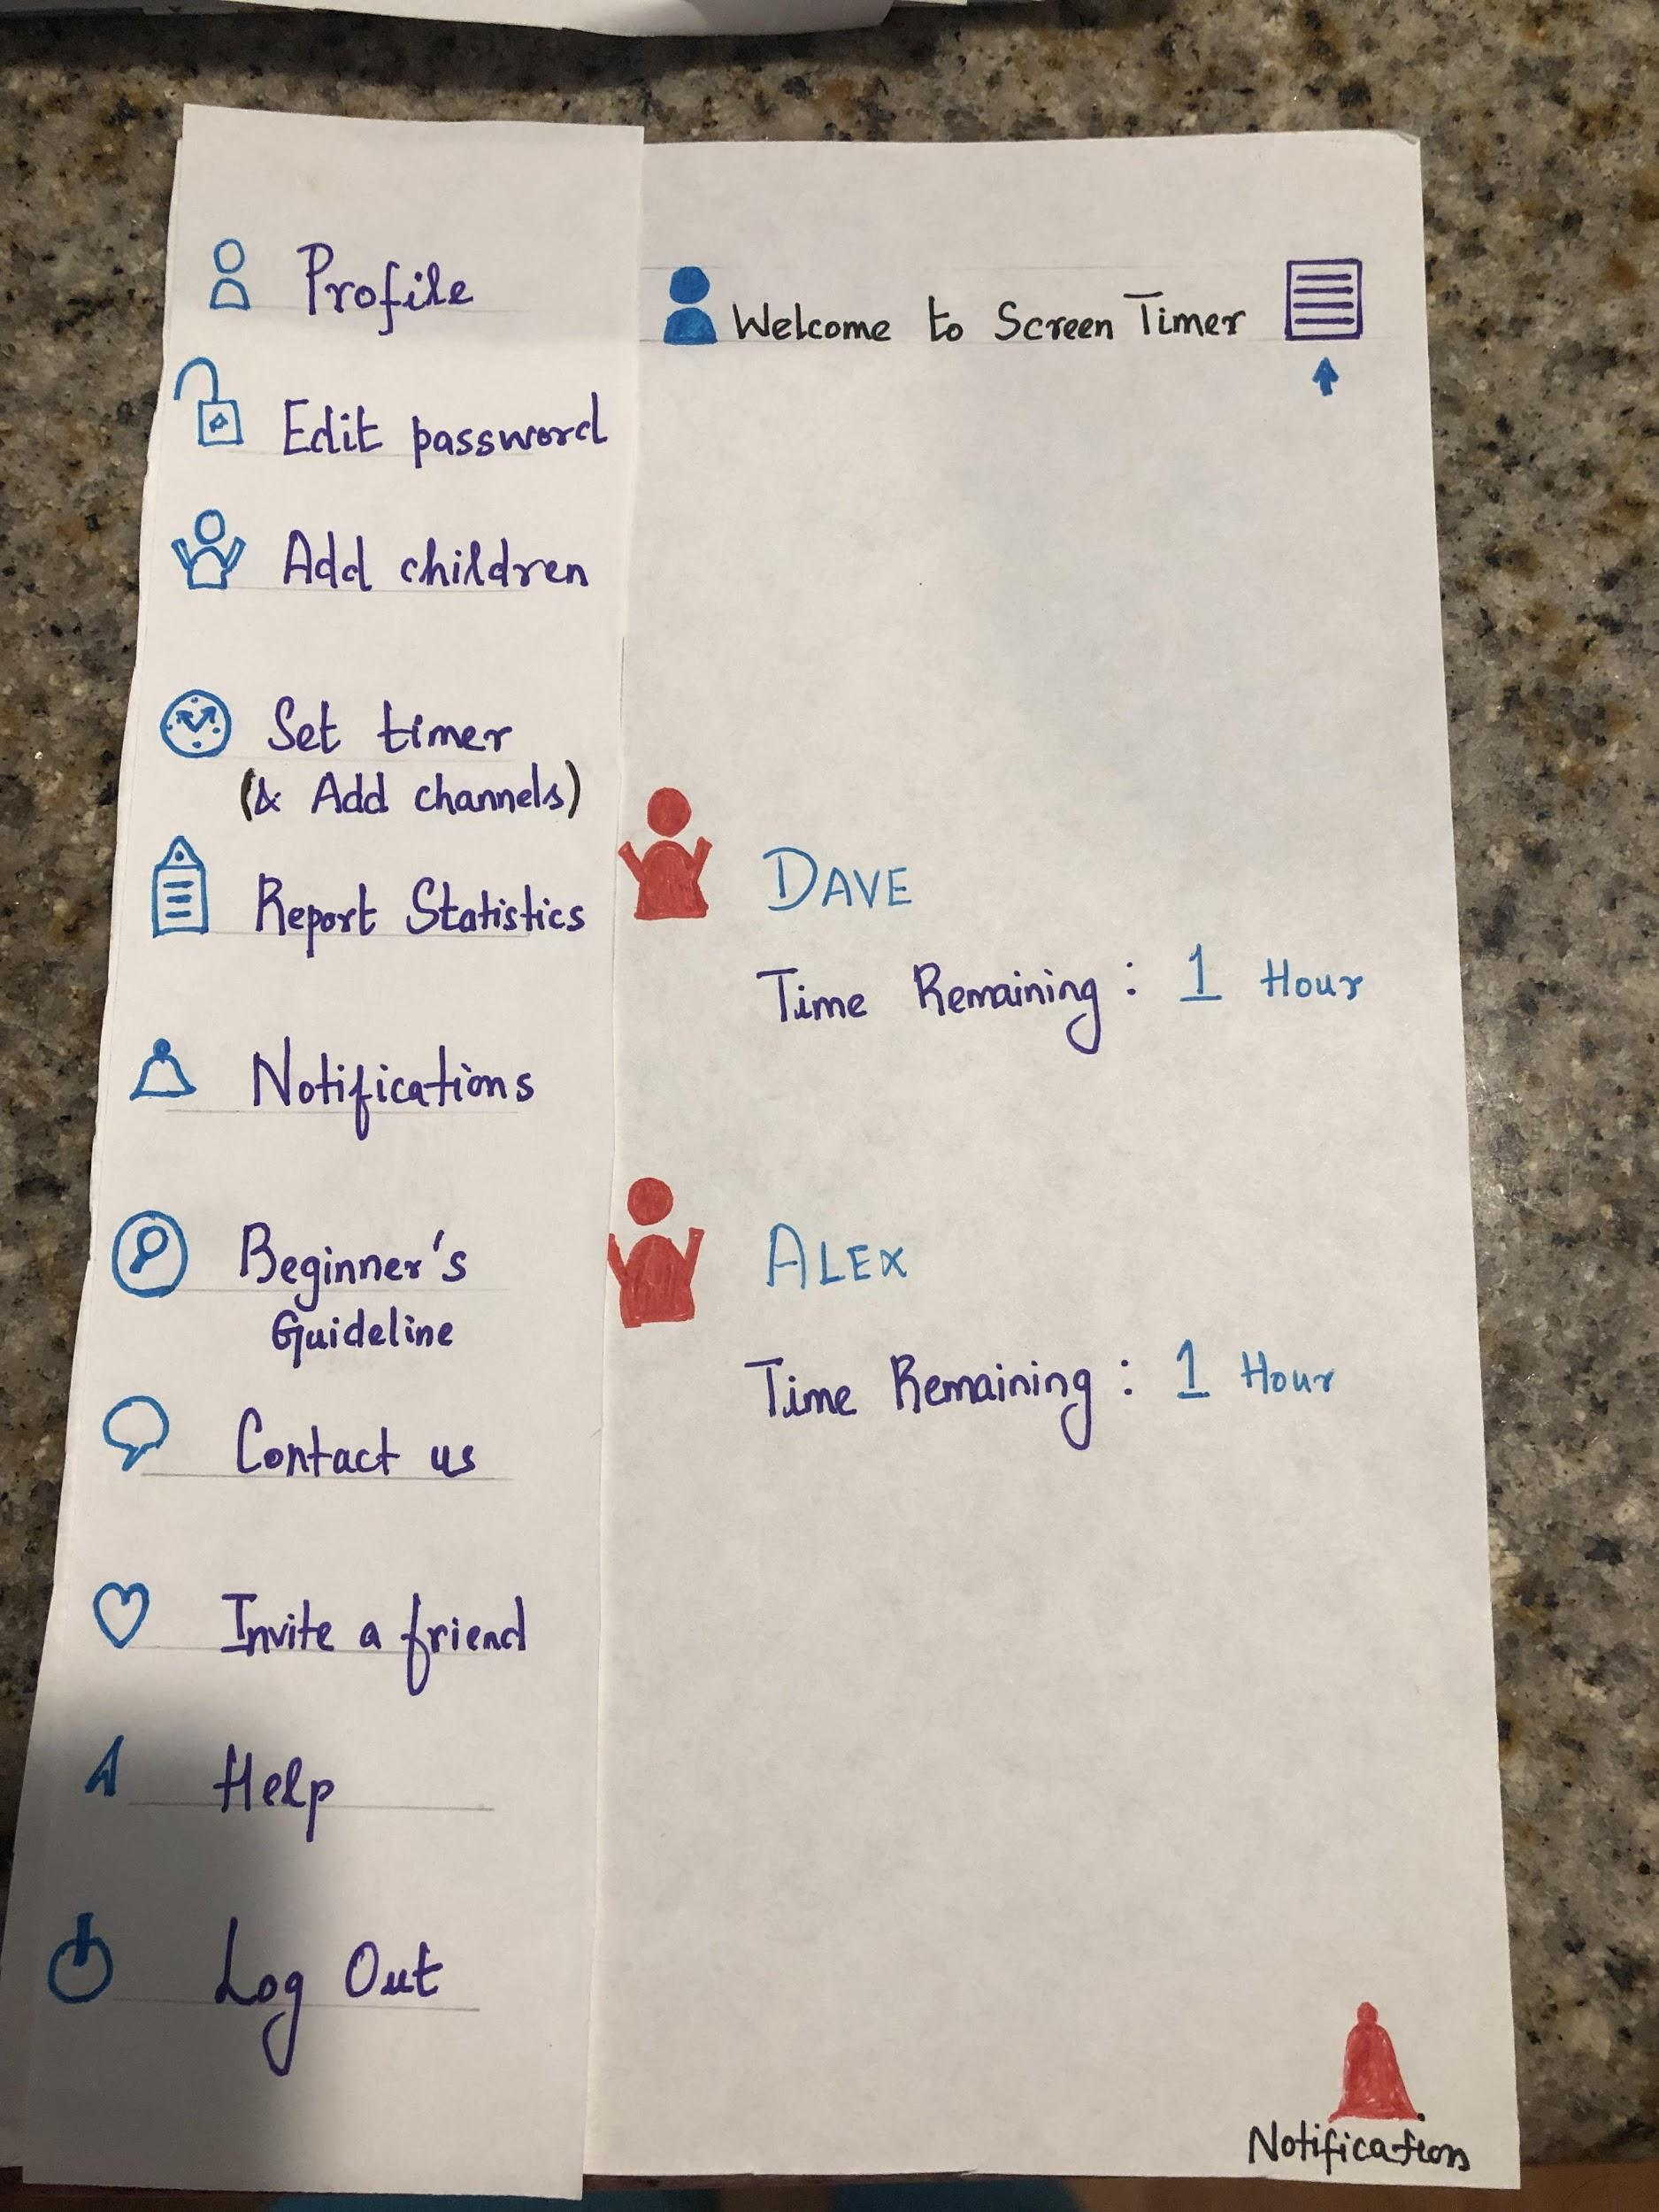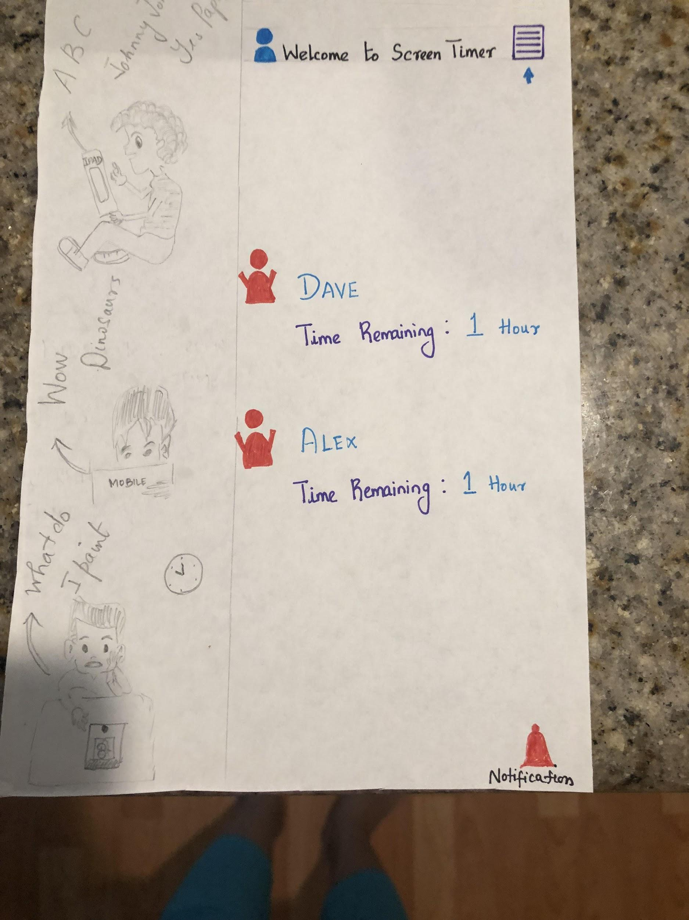

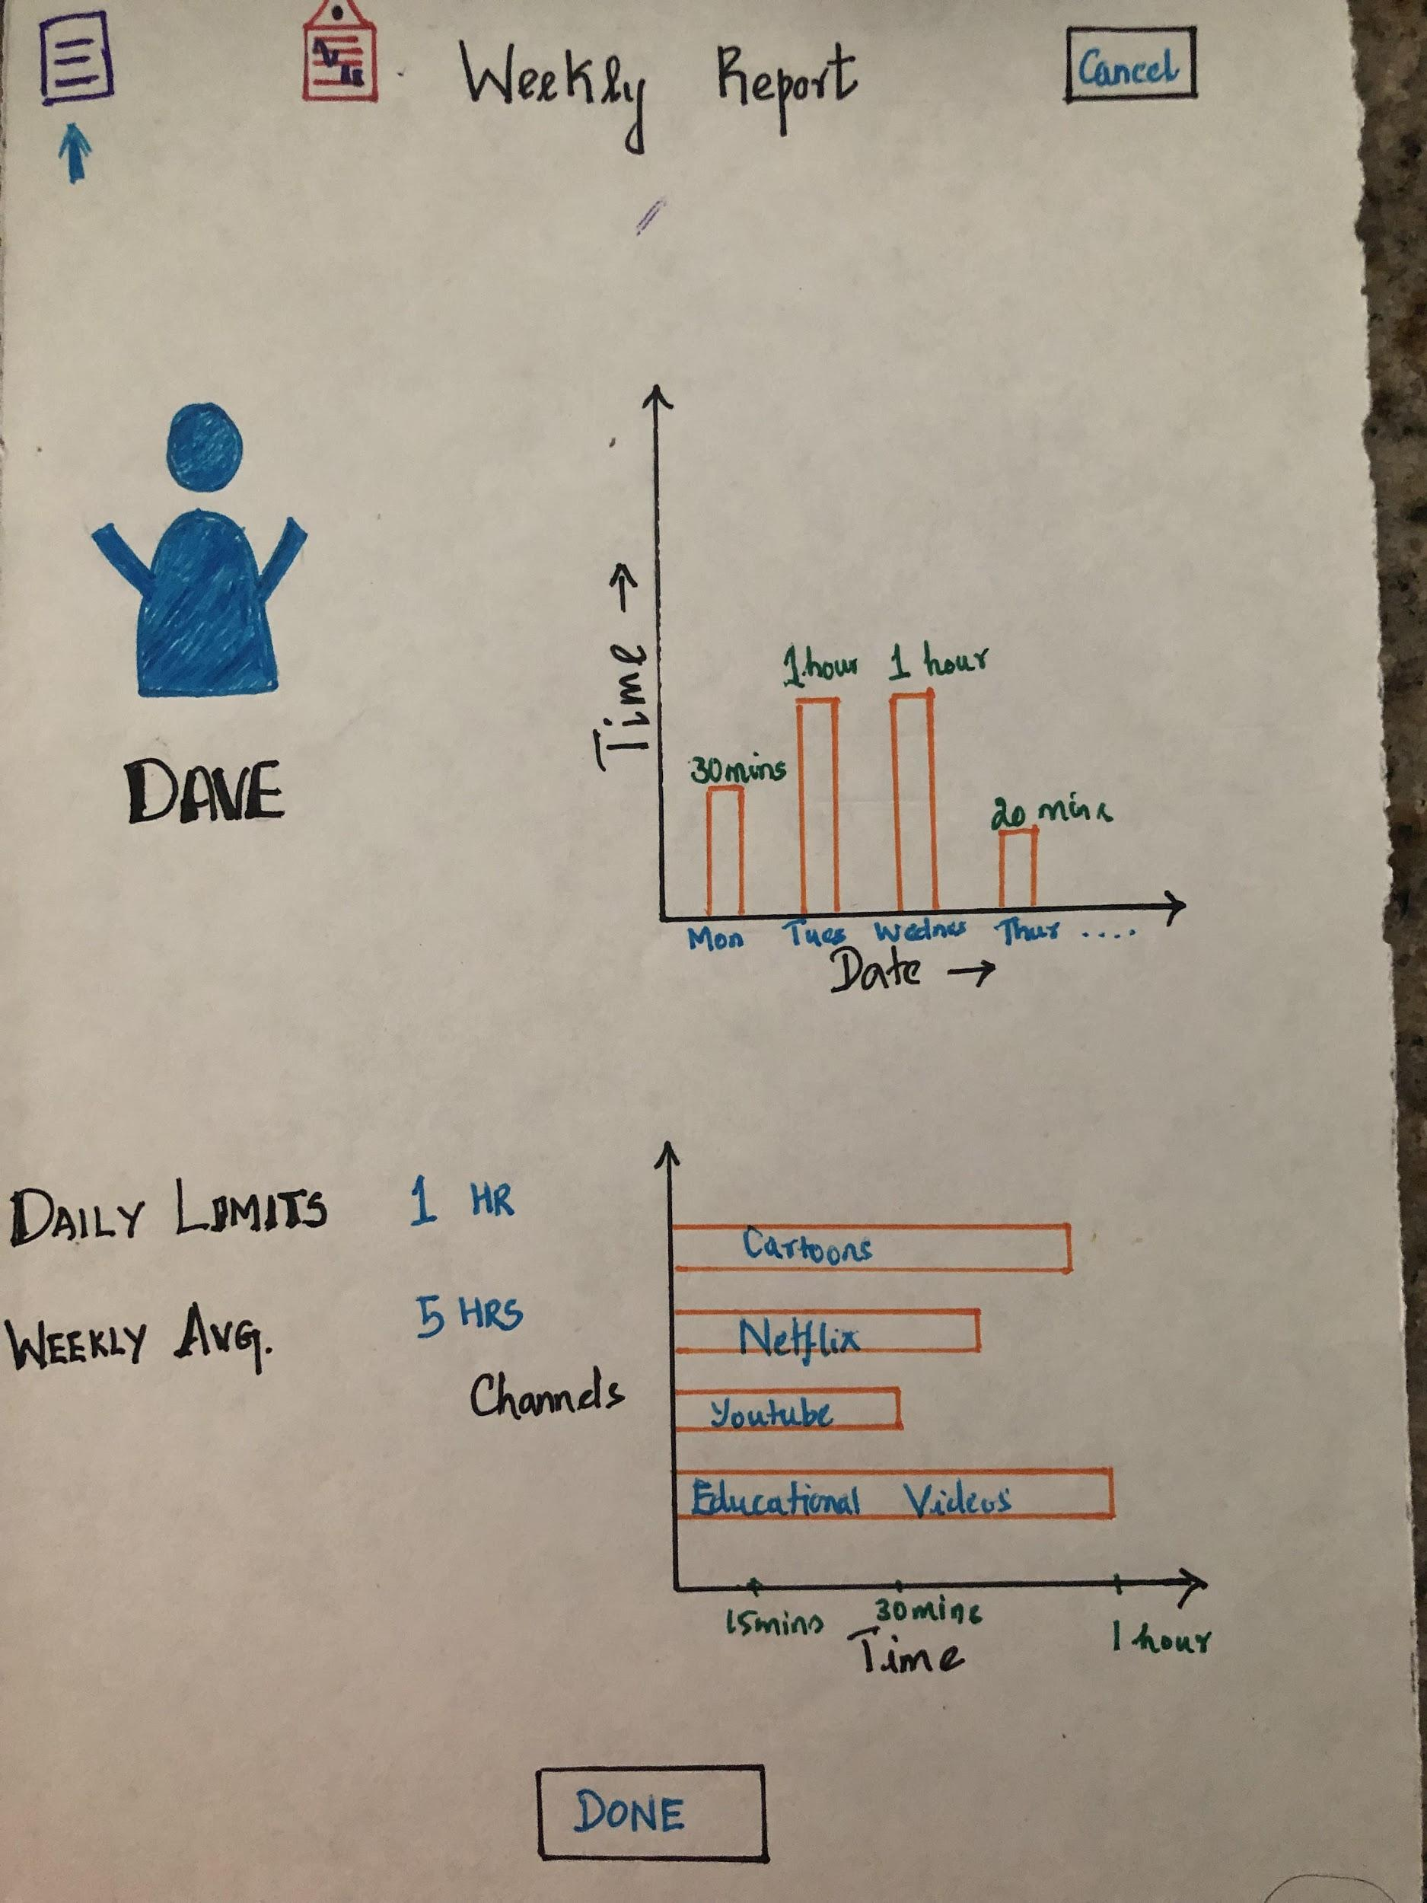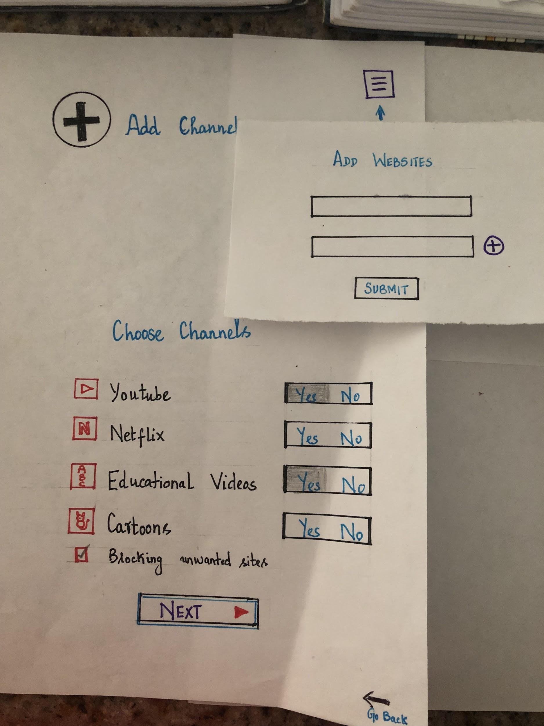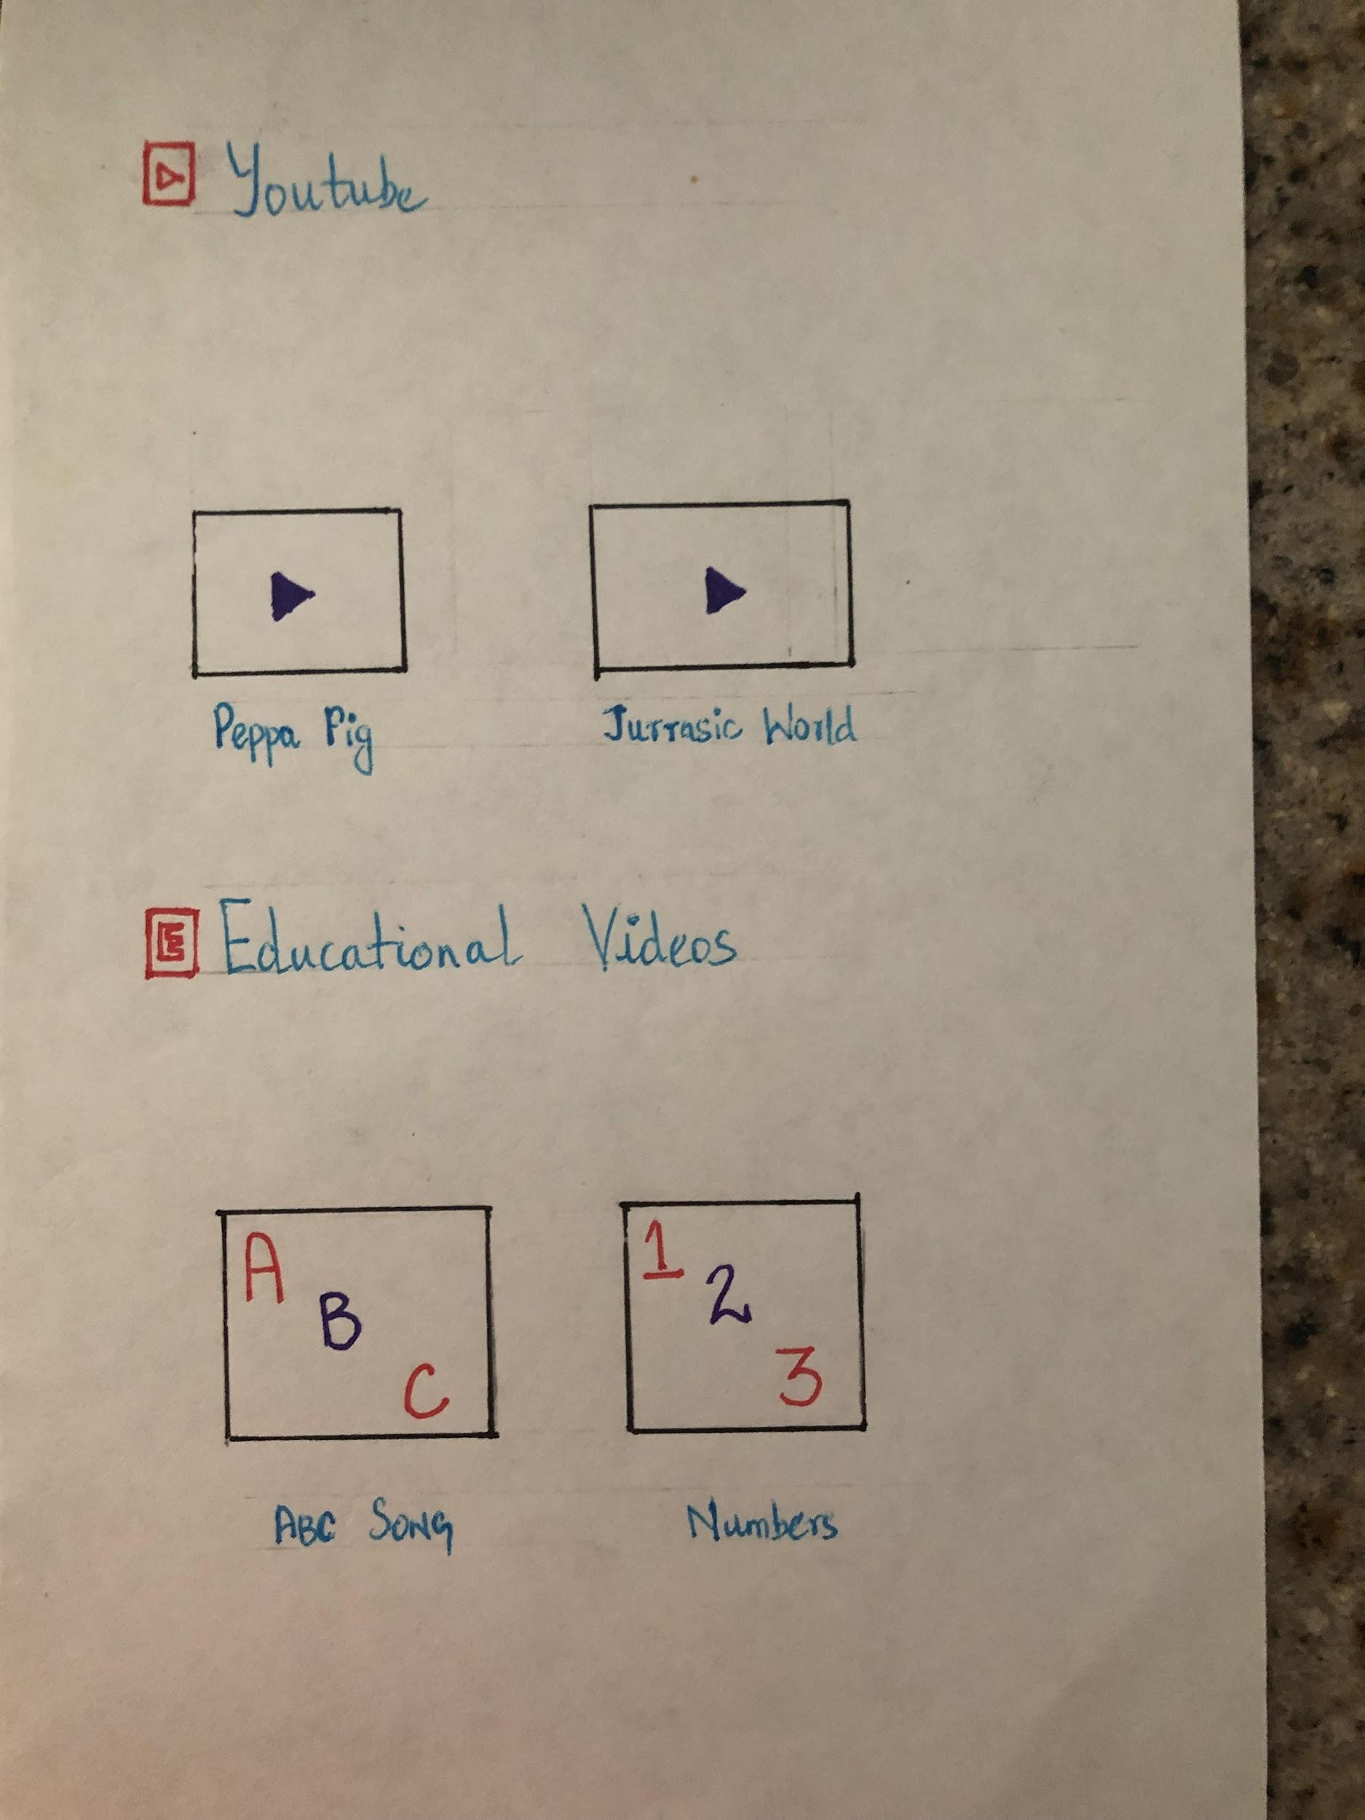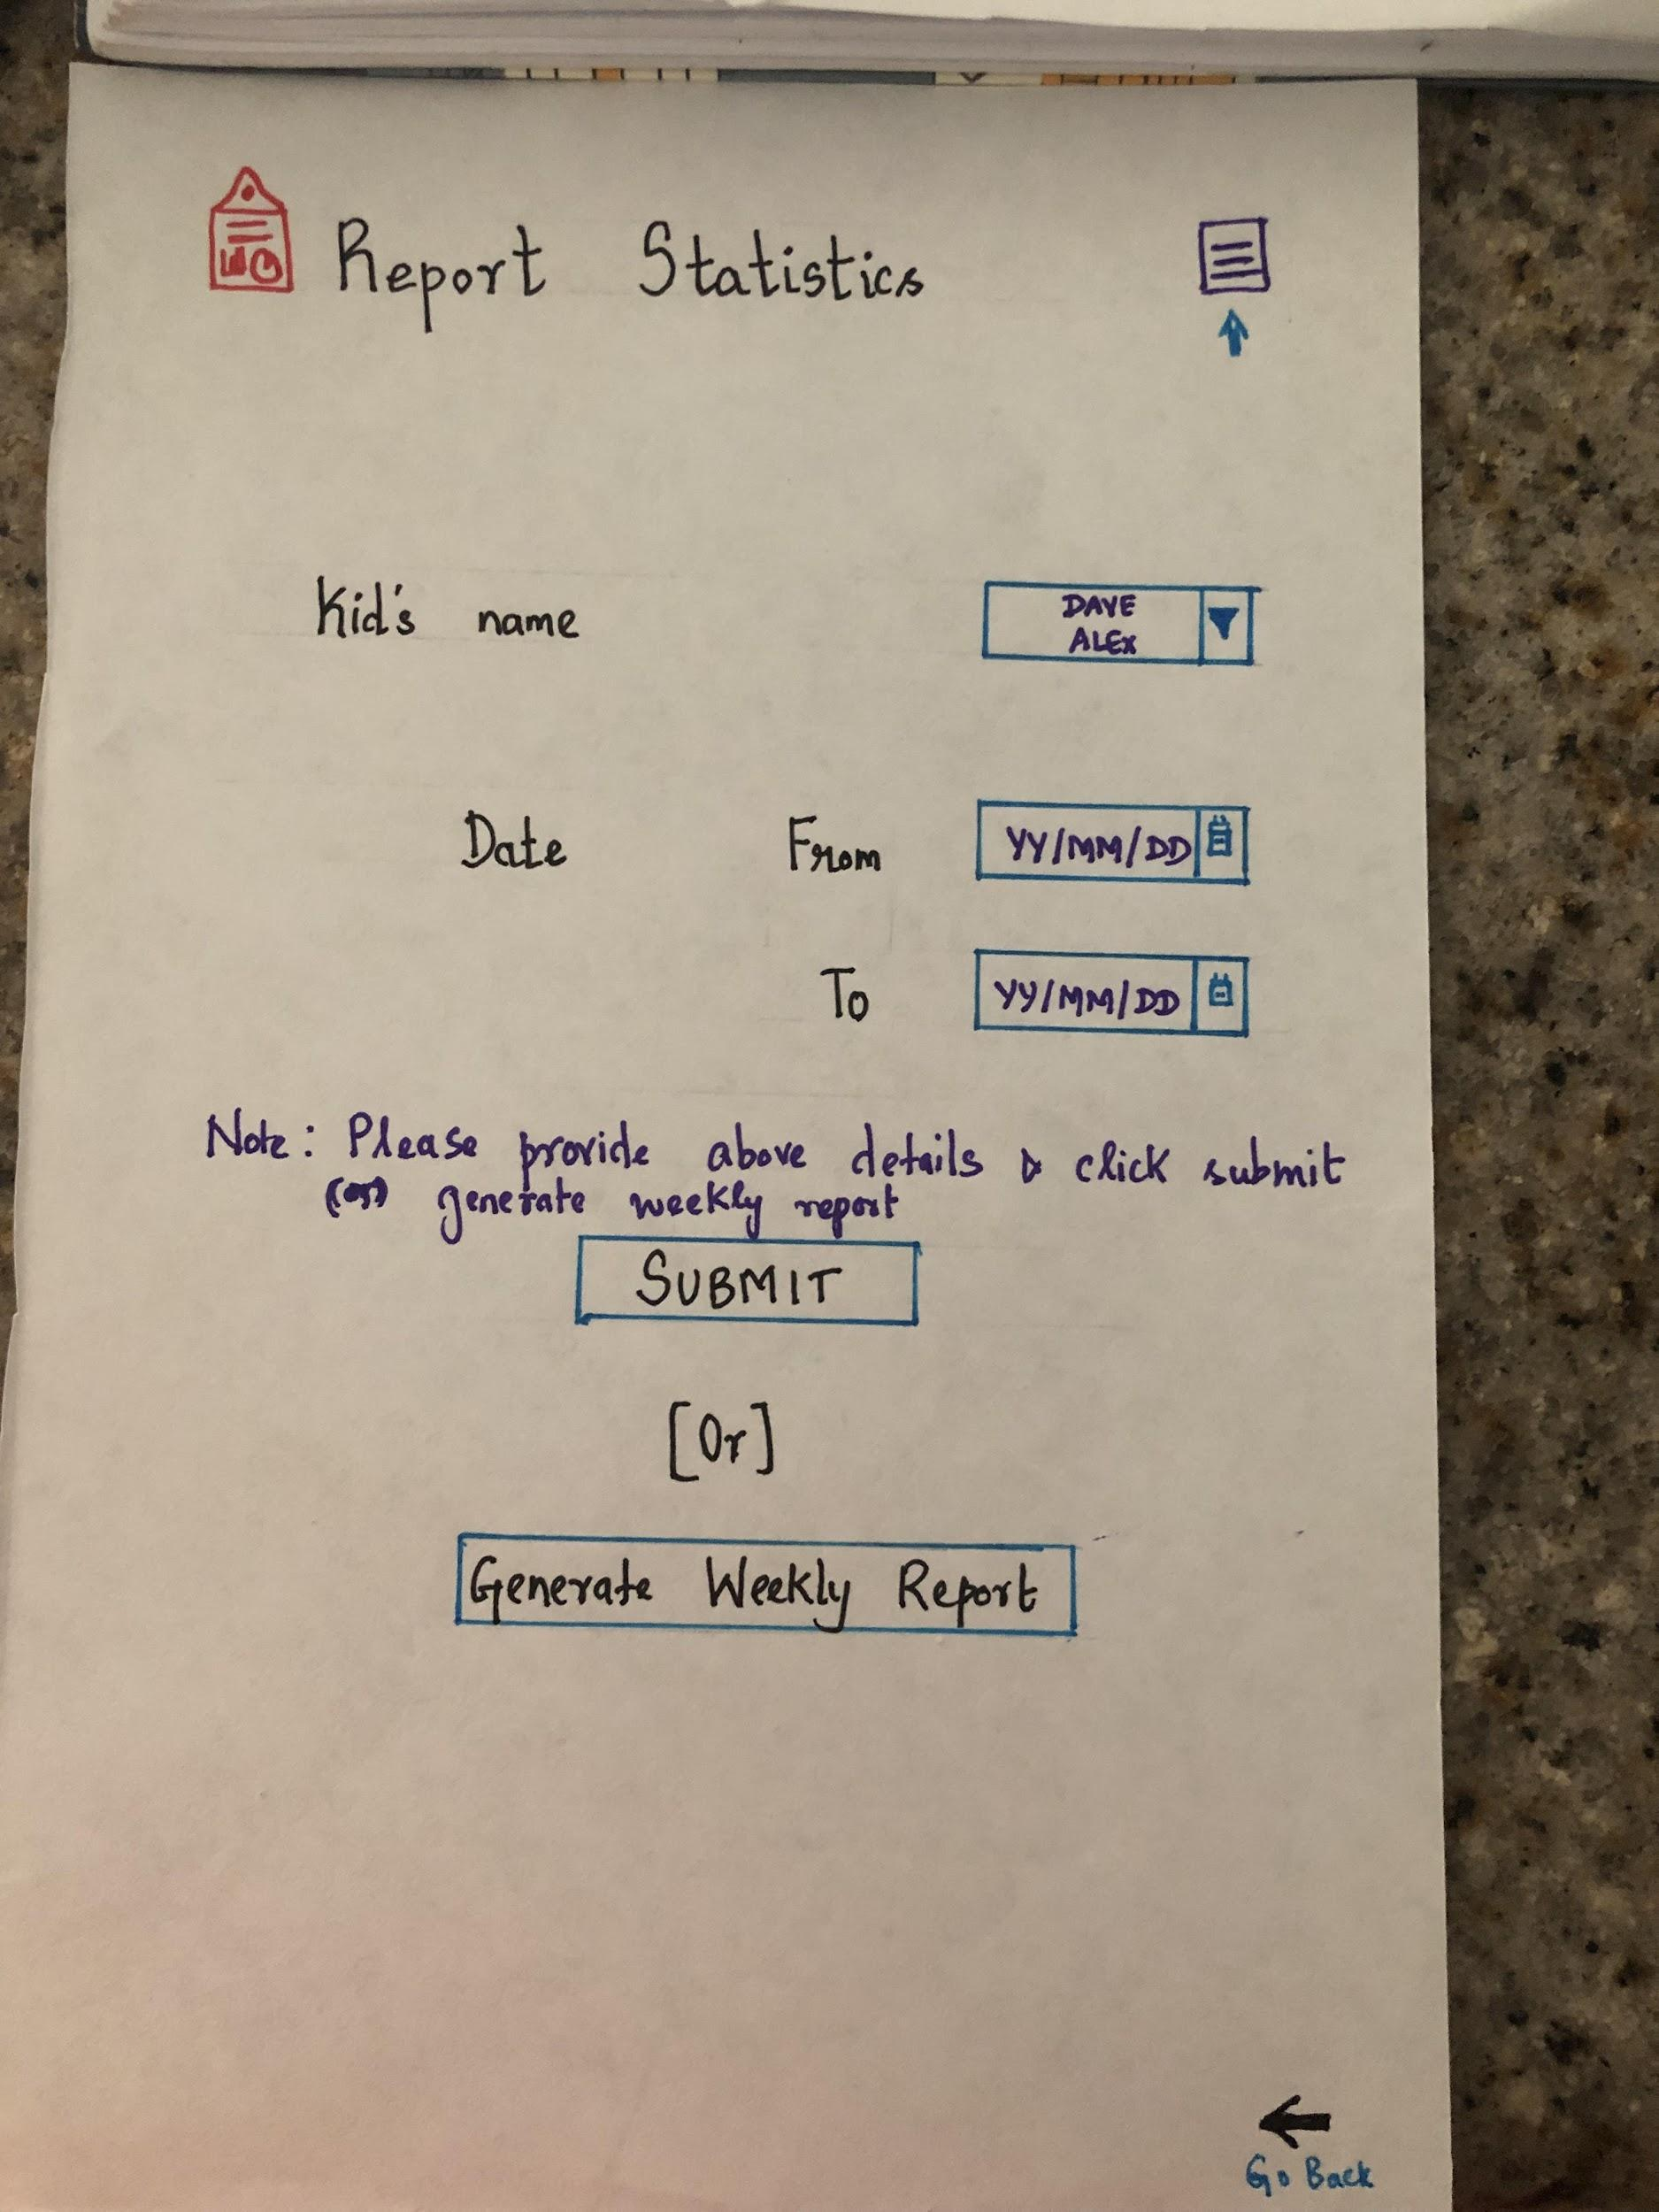

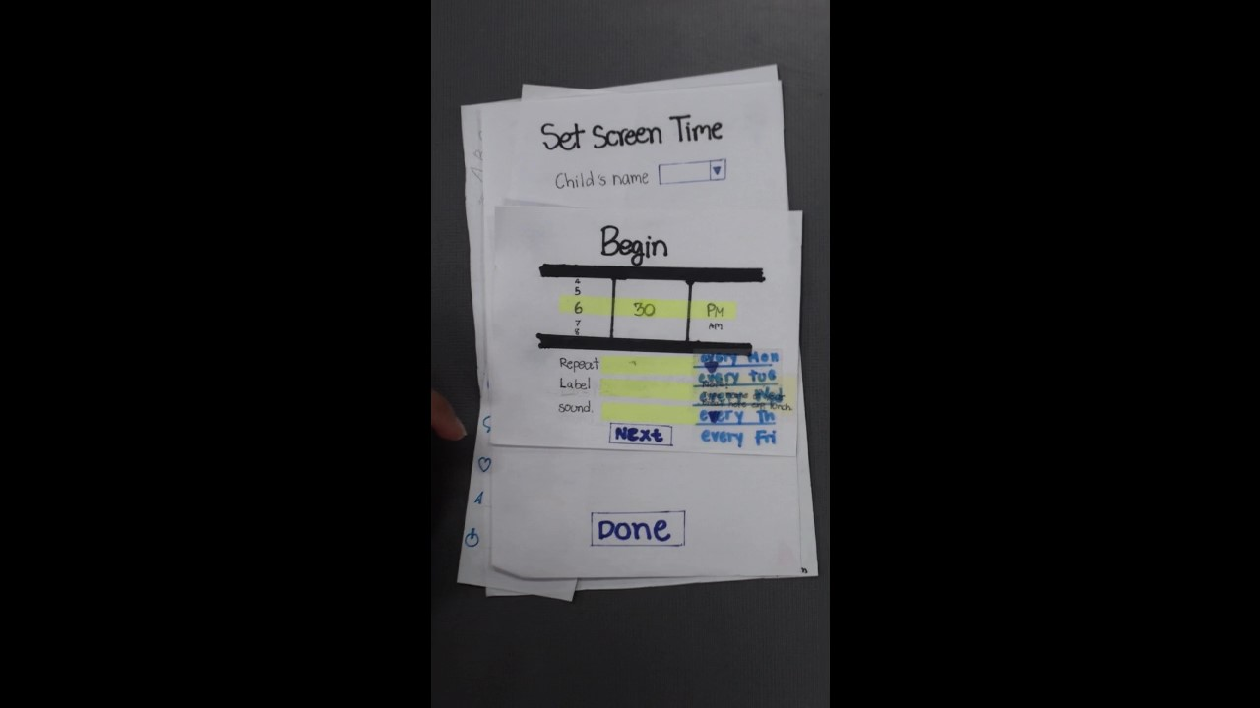

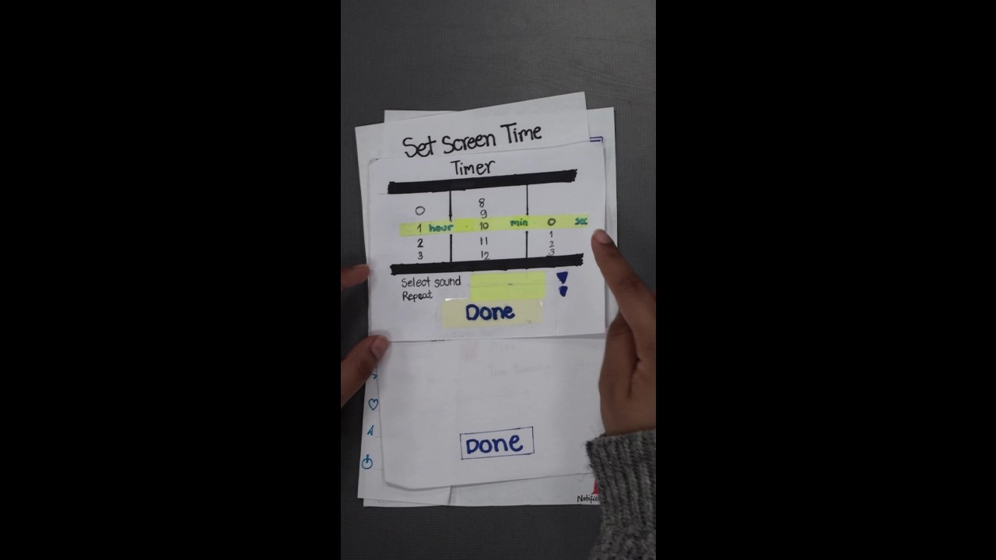

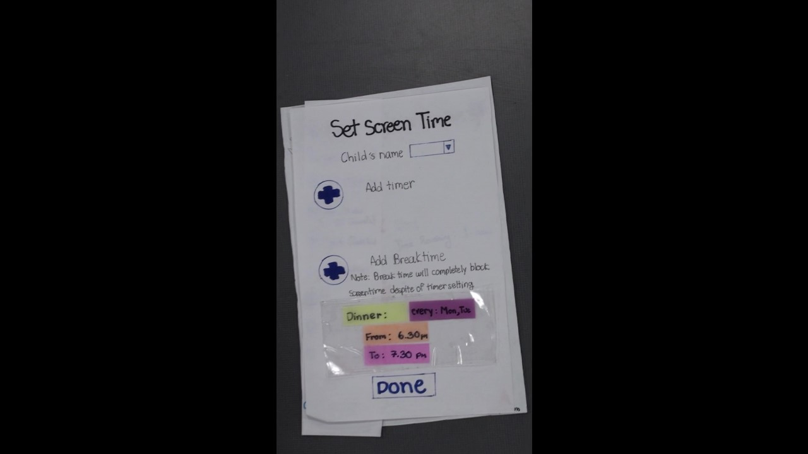

10: Usability Test (Low-fidelity)

Member’s role:

Facilitator : Karthika Dharmia Rajendran

Coordinator : Julalak Boonleerawat

Observers : Kevin Lim

Samira Muna

Usability test video link:

https://drive.google.com/file/d/1pSrqW_6qUwrBcXO_HZIORyMKaASJgXSY/view?usp=sharing

Scripting of facilitator and Video Transcript

Facilitator script :

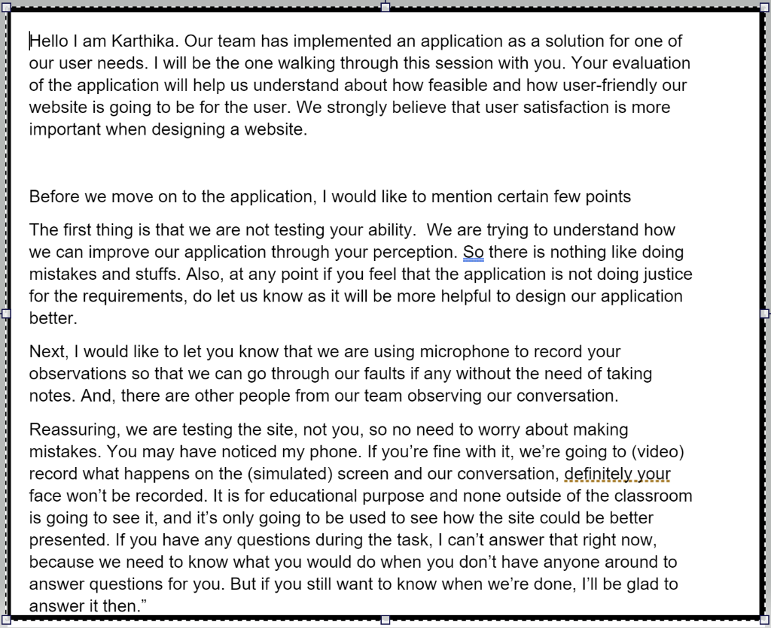

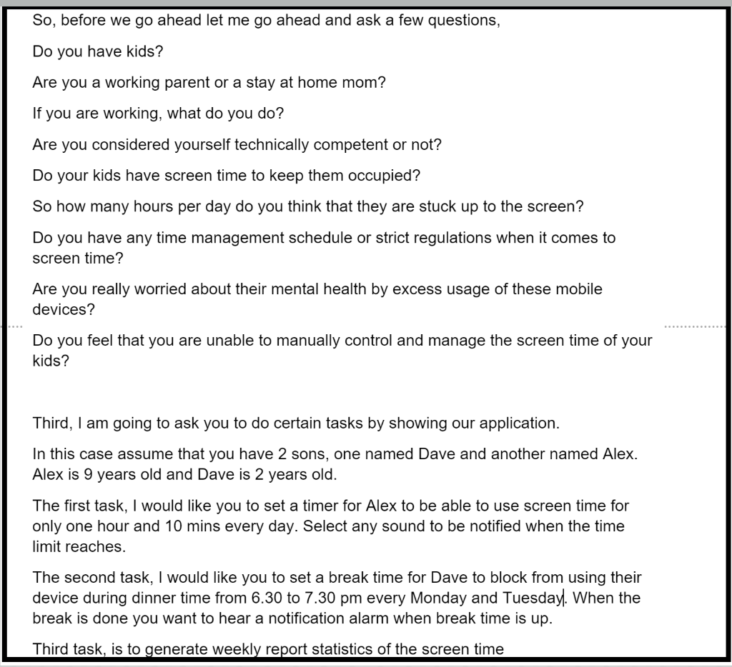

Transcript of the facilitator with the user during usability test:

Hello I am Karthika. Our team has implemented an application, as a solution for one of our user needs. I will be the one walking through this session with you. Your evaluation of the application will help us understand about how feasible and how user-friendly our website is going to be for the user. We strongly believe that user satisfaction is more important when designing a website.

Before we move on to the application, I would like to mention certain few points

The first thing is that we are not testing your ability. We are trying to understand how we can improve our application through your perception. So there is nothing like doing mistakes and stuffs. Also, at any point if you feel that the application is not doing justice for the requirements, do let us know, as it will be more helpful to design our application better.

Next, I would like to let you know that we are using microphone to record your observations so that we can go through our faults if any without the need of taking notes. And, there are other people from our team observing our conversation.

Reassuring, we are just testing the site, and not you, so you do not have to worry about making mistakes.

You may have noticed my phone recording our screen and conversation so that we understand our faults better without the need to take notes. Definitely your face won’t be recorded. It is for educational purpose and none outside of the classroom is going to see it, and it’s only going to be used to see how the site could be better presented.

If you have any questions during the task, I can’t answer that right now, because we need to know what you would do when you don’t have somebody around to answer questions for you. But if you still want to know when we’re done, I’ll be glad to answer it then.”

So, before we go ahead let me go ahead and ask a few questions:

Are you a parent? ---Yes

Are you a working parent or a stay at home mom? --- Stay at home mom

Are you considered yourself technically competent or not? --- Pretty competent

Do your kids have screen time to keep them occupied? --- Yes

So how many hours per day do you think that they are stuck up to the screen? --- Probably 3 hrs per day

Do you have any time management schedule or strict regulations when it comes to screen time? --- I feel like there should be a way to have only a couple of hours and have the screen turn off by itself because too much screen time isn’t good

Are you really worried about their mental health by excess usage of these mobile devices? --- Yes

Do you feel that you are unable to manually control and manage the screen time of your kids? --- Yes because once the timer is off they can click the other button and I wouldn’t know

Thank you for answering the questions so patiently. Now I am going to give you a set of tasks to be performed. We will go through the application.

So, what do you think this is, this application is about? --- This application is for the use of children and it shows time remaining so they have a time limit on other apps.

How do you feel about the application, what does it lead to? --- Okay, I’m guessing I have to click this first. Okay, so this is easy if I have multiple children. I can click this.

The first task is that assuming you have two kids named Dave and Alex. First task is that I would like you to set a timer for Alex to be able to use screen time for only one hour and ten minutes everyday and select some alarm, radar, for when that specific time is reached. How would you proceed? --- I would click set timer, I would put my child’s name Alex, and then I would click this first and add the timer. Then I would put that time and select a sound, which is very loud so I would be able to hear it as well. I’ll click radar and then hit done.

Thank you for doing the task. The second one is that I’d like you to set a break time for Dave to block from using the device during dinner time from 6:30 to 7:30pm every Monday and Tuesday and some alarm if you wish. --- I’ll click 6:30, repeat everyday. I’ll choose label Dinner, and sound would be same as the last task. Click Next. Click Done.

Thank you. Next task, we would like you to see a weekly report of how much time you kid is using the screen. --- Okay, I will click weekly report. Click Yes. Enter my email. Press submit.

You did it, great! Another thing I wanted to add. Do you feel that this is really cool and easy? --- Yes, super easy.

We are designing this app to be useful even for technically incompetent individuals, so we have added some tasks for that as well. In case, a parent is not able to understand how out application works and they might need a guide. If you need some assistance, what task would you be performing on the screen? --- I would have different languages and when I click something I want it to say what it’s for. If I was incompetent, I would want the app to tell me, have steps or popups. Such as step 1…

Thank you for your feedback. We do have other members of our team observing and they have some questions to be asked regarding the application as well. It would be great if you can provide answers to those questions.

Hi, I’m Samira. I’m going to ask you a few questions to conclude this usability test. First question, on a scale of 1 to 10, 1 being the least and 10 being the most, how difficult was this test? --- It was like 1

There were three tasks involved today, which did you find most enjoyable? The first task was setting a timer, the second task was setting a break time, and the third was a weekly report. --- The weekly report because it tells me how much they’ve used what apps.

What did you find least enjoyable? --- I don’t have a least enjoyable task

What do you think are some things we can improve on? --- If someone was incompetent, I think it would be easier for them to have popup steps, a setting box that shows an option for steps, and an option for what language you speak.

Would you use this app personally? --- Yes, I would because the way the app is built is easy and there’s no subscription and I like the weekly statistics.

Do you feel this can improve the life of a child in terms of mental health? --- Yes because I feel screen time is a new thing children are using and it does affect their performance in school and overall mental health.

That’s about it, thank you for your time.

Once again I’d like to introduce myself as well as the team. I’m Karthika, the facilitator. We have Julalak, the coordinator. We also have Samira and Kevin as the observers. Thank you so much for participating; we appreciate your feedback.

**Observers notes**

* The user got confused on drop down options. She didn’t recognize the drop down options we intentionally put on, but the one, we did not put on she thought, they are.
* The user does not have English as her first language
* User was not talkative. She was not as much as descriptive as we wish her to
* Overall the tasks did not seems difficult for her. She had confidence that she would be able to do it.
* At certain times, the “screen changing” did not go as smoothly, which made the interactions a little confusing for the user. --- 3 on level of severity
* A few times the user would ask the facilitator questions and the facilitator wouldn’t be able to answer, so the user would be stuck for a few seconds before moving on with the test. --- 3 on level of severity
* Calendar button in report and statistic got the user a pause and a little bit of confusion before she could move on by herself

**User’s feedback**

Overall, the user was very much satisfied with the design of the low fidelity paper prototype, and provided very good feedback.

Some questions were asked at the end of the test to get the overall opinion of the user’s experience, and are provided below:

**Question**: On a scale of 1-10, 1 being the least and 10 being the most, how difficult was this test?

***Ans*** *: I would give it a 1. It wasn’t very difficult.*

**Question**: There were three tasks involved, which did you find most enjoyable?

***Ans*** *:* *I would say the weekly report was most enjoyable to work with.*

**Question**: Which did you find least enjoyable?

***Ans*** *: I honestly didn’t find any of the activities least enjoyable. I was satisfied with all of them.*

**Question**: What are some things we can improve on?

***Ans*** *:* *I think it would be easier to have pop up steps or a box that lists all the steps on how to use the app for people who are technically incompetent, and an option for language choice for people that don’t have English as their native language.*

**Question**:Would you use this app personally?

***Ans*** *:I would because the app is built in such a way that it’s easy to use, there’s no subscription, and I like the weekly report.*

**Question**: Do you feel this can improve the life of a child in terms of mental health?

***Ans*** *: Yes because it’s a new thing and I feel that technology can affect children`s performance negatively.*

**Assessment of Test’s Results**

The assessment of the test’s results were created to justify the changes for the next iteration of the prototype. We found out that there is a major accessibility issue in our low fidelity prototype. We would rate the severity of not implementing language option in the menu as ‘3’.

Our application do focuses on handling requests of technically incompetent parents by just providing beginner`s guidelines that lists out the details of all the menu options in detail. In that case, as per the user feedback, we should implement the language option as well for the application to be accessible by parents of all cases.

The drop down options and buttons should be made to be clear and noticeable in the same format for it to have consistency. There should be no calendar button. There someway that are more general and users don’t have to go deep down into a specific day in the calendar. It would faster the process much more.

Contact us needs to be combined with Help because we want to group things that are related to each other in the same place, so there will not be many pages. We want it to be simple and straightforward.

**Usability Test Assessment Report link :**

**https://drive.google.com/file/d/1VsXEU2kt5XsmcVQwScT9lyT_rb_vycaf/view?usp=sharing**

11: Usability Test (High-fidelity)

**Member’s role: Facilitator, observers, player(as computer)**

Facilitator : Kevin Lim

Observers : Karthika Dharmia Rajendran, Julalak Boonlerawat, Samira Muna

**Scripting of facilitator:**

Hello Mary, my name is Kevin. Thank you for your time and today you’ll be helping us test our app out. Your perspective would be very helpful in polishing our work so I encourage you to narrate your actions as it and say what you're looking at and made sure, well, et Cetera, et Cetera, which is the side now you so don't be nervous, you can't do anything wrong. Um, if you have any questions just ask away. I will or will not be able to answer them depending on what they are. And if tell us if you need any assistance and if you have any questions then we'll answer them and if you need a break at any point, just tell us. We will be recording our activity as well as your voice. Is that okay?

And do you have any questions so far though?

So before we started out with a few questions, do you have any kids?

How old are they?

Do you own a computer, laptop, or smartphone?

And how adequate are you, how savvy are you with them?

And do your kids use them as well?

Have you ever wished to limit their usage of the devices?

So let's go to the prototype. And just click around and see how, see how it is and do you have any impressions on it?

Ok so I am passing you some tasks with some scenarios. There you go.

So the first one is with your son. Your son's name is Dave. He's one year old, he's rambunctious and unruly and he's on your tablet more than you feel comfortable with. Can you limit his time to three hours for Saturday only.

Next one, you feel like he’s not spending enough time with you, so you want to set aside some time for him. You want to make sure that Dave isn't on tablet at a, at a specific time. Make it so we cannot get on from three to 4:00 PM.

Now, Dave has somehow gain to your Facebook account and posting random pictures. Restrict his access to Facebook.

The next task is that you thought a show seemed friendly called Happy Tree Friends but their website isn’t what you thought it was. Turn off his access to the website.

If you want to see Dave’s activity for last week, can you generate a report on it and send it to your email?

You like to check on you other son, Alex, on his activity. Change the screen time’s focus to Alex.

You’re done with all of the tests, thank you very much. It's very helpful. And here we have Karthika, Julie and Samira as our observers.

**Observers notes:**

**Karthika`s notes :**

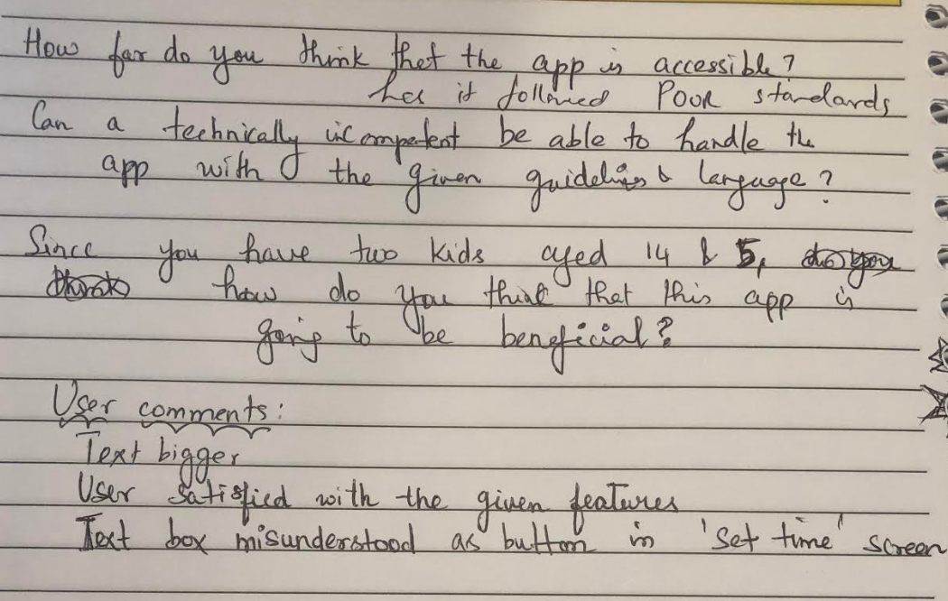

The above questions regarding the accessibility issues were asked to the user and the

feedback was obtained. The user was happy with the application and was expecting further

enhancements to the product.

**Julie’s Note**

* The user think that we should go deep down into specific contents of what the kid is watching

For example instead of just saying YouTube 24 mins, we should put

Youtube : Tony The Train Parody

* User are very concerned language used and violent acts in the video content
* User think that text should be bigger and we have enough space to make each element bigger
* User like the simplicity of the application
* User still want more contrast in homepage buttons

**Samira’s Notes**

User’s behavior during test:

She definitely thought out loud during the test. The group was able to understand what the user was feeling during the tasks portion of the test. She seemed to play around with all the options one by one, when given a specific task, rather than just tackle the assignment right away.

User was very calm. There was no sign of nervousness. She was very attentive to the screen. She was able perform the tasks given. It wasn’t a situation where she couldn’t figure it out at all and totally gave up. That’s a good sign on our part.

User’s feedback on test:

She gave us positive feedback. She only had a few concerns. One being the need for bigger text and buttons. Another being a better color contrast between elements. We kept those in mind.

**Documenting the process (video tape and transcripts of the video)**

* **Usability test link :**

[**https://drive.google.com/file/d/1SfKf26Nt0RpL3PxloTgagsj6GE535L55/view?usp=sharing**](https://drive.google.com/file/d/1SfKf26Nt0RpL3PxloTgagsj6GE535L55/view?usp=sharing)

* **Transcript Link:**

**https://drive.google.com/file/d/12KD_KRIh3Cpjh920km9Iv8vCmWOSnjC3/view?usp=sharing**

**Assessment of test’s results; plan for next iteration**

* **Assessment report link:**

**https://drive.google.com/file/d/1w45gUVRzhI6HPpaIpXkEH-BpVz8awiDj/view?usp=sharing**

* **Further iteration:**

**The application can be further enhanced to include additional features mentioned by the user, like producing a report on the specific details of what the child watched on youtube and so on.**

**12: Heuristic Assessment Evaluation on High Fidelity**

* **Group Name:** Accessible Boys
* **Evaluated Application Name:** NotifyMe
* **Task/s:** Add your account (Gmail)
* **Heuristic Evaluation Guideline:** See images below for checklist
* **Member’s Documentation:**

***Samira*** :-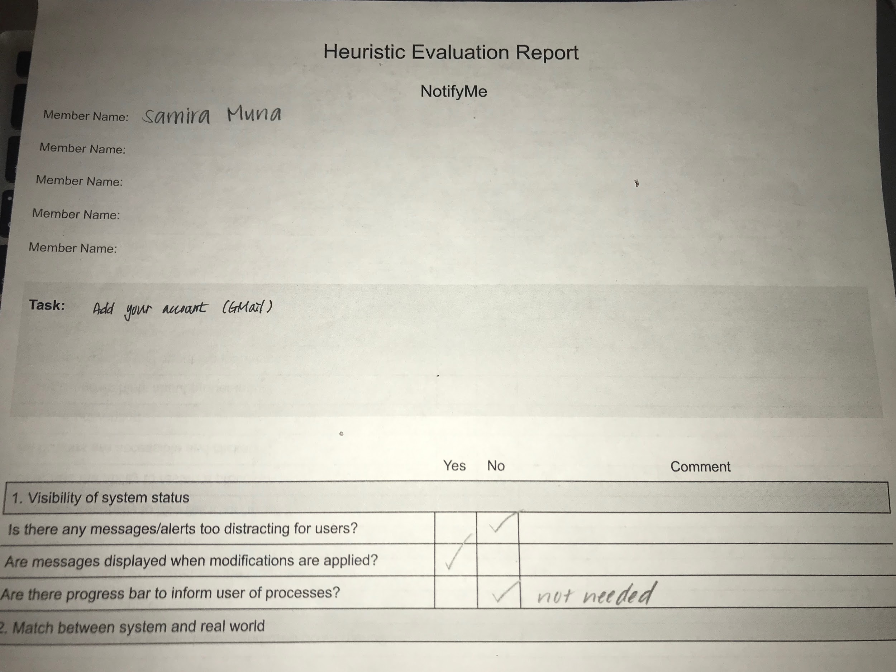

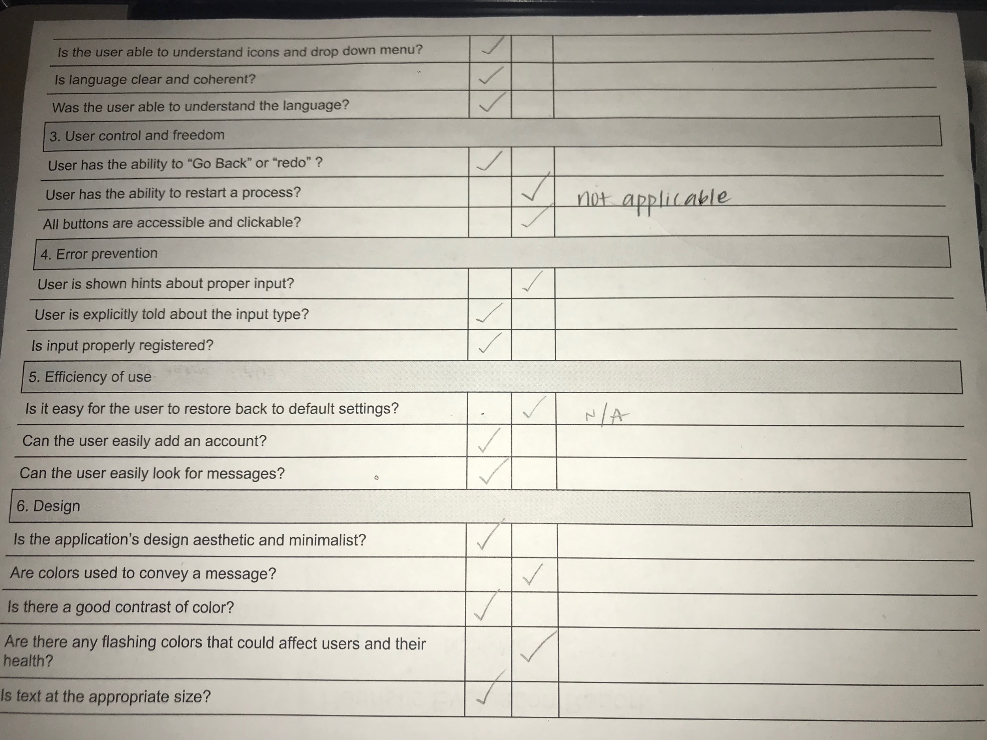

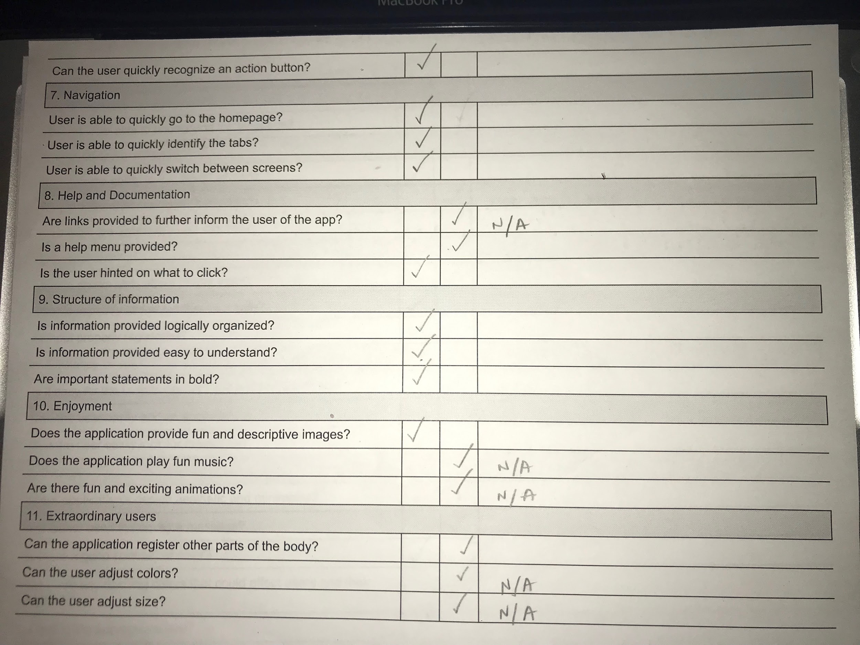

**Karthika`s Checklist** 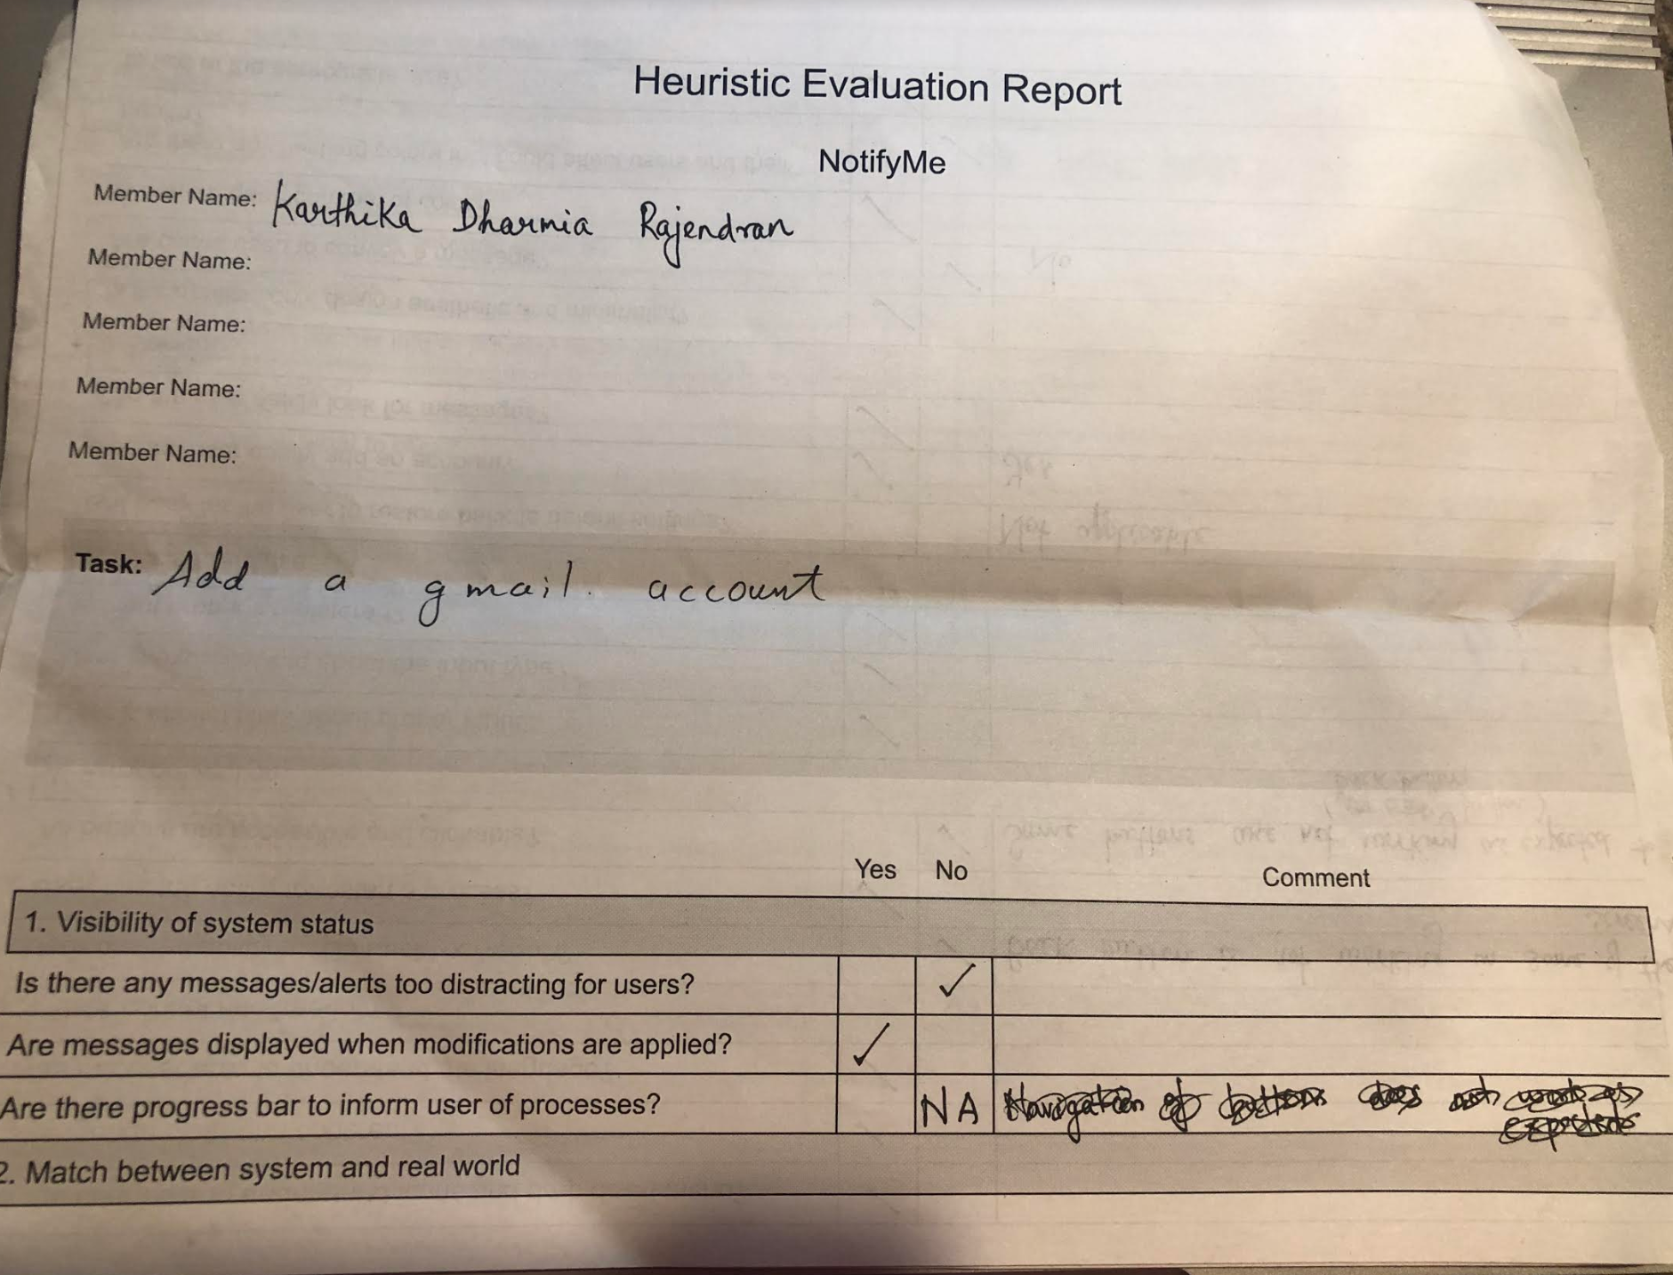

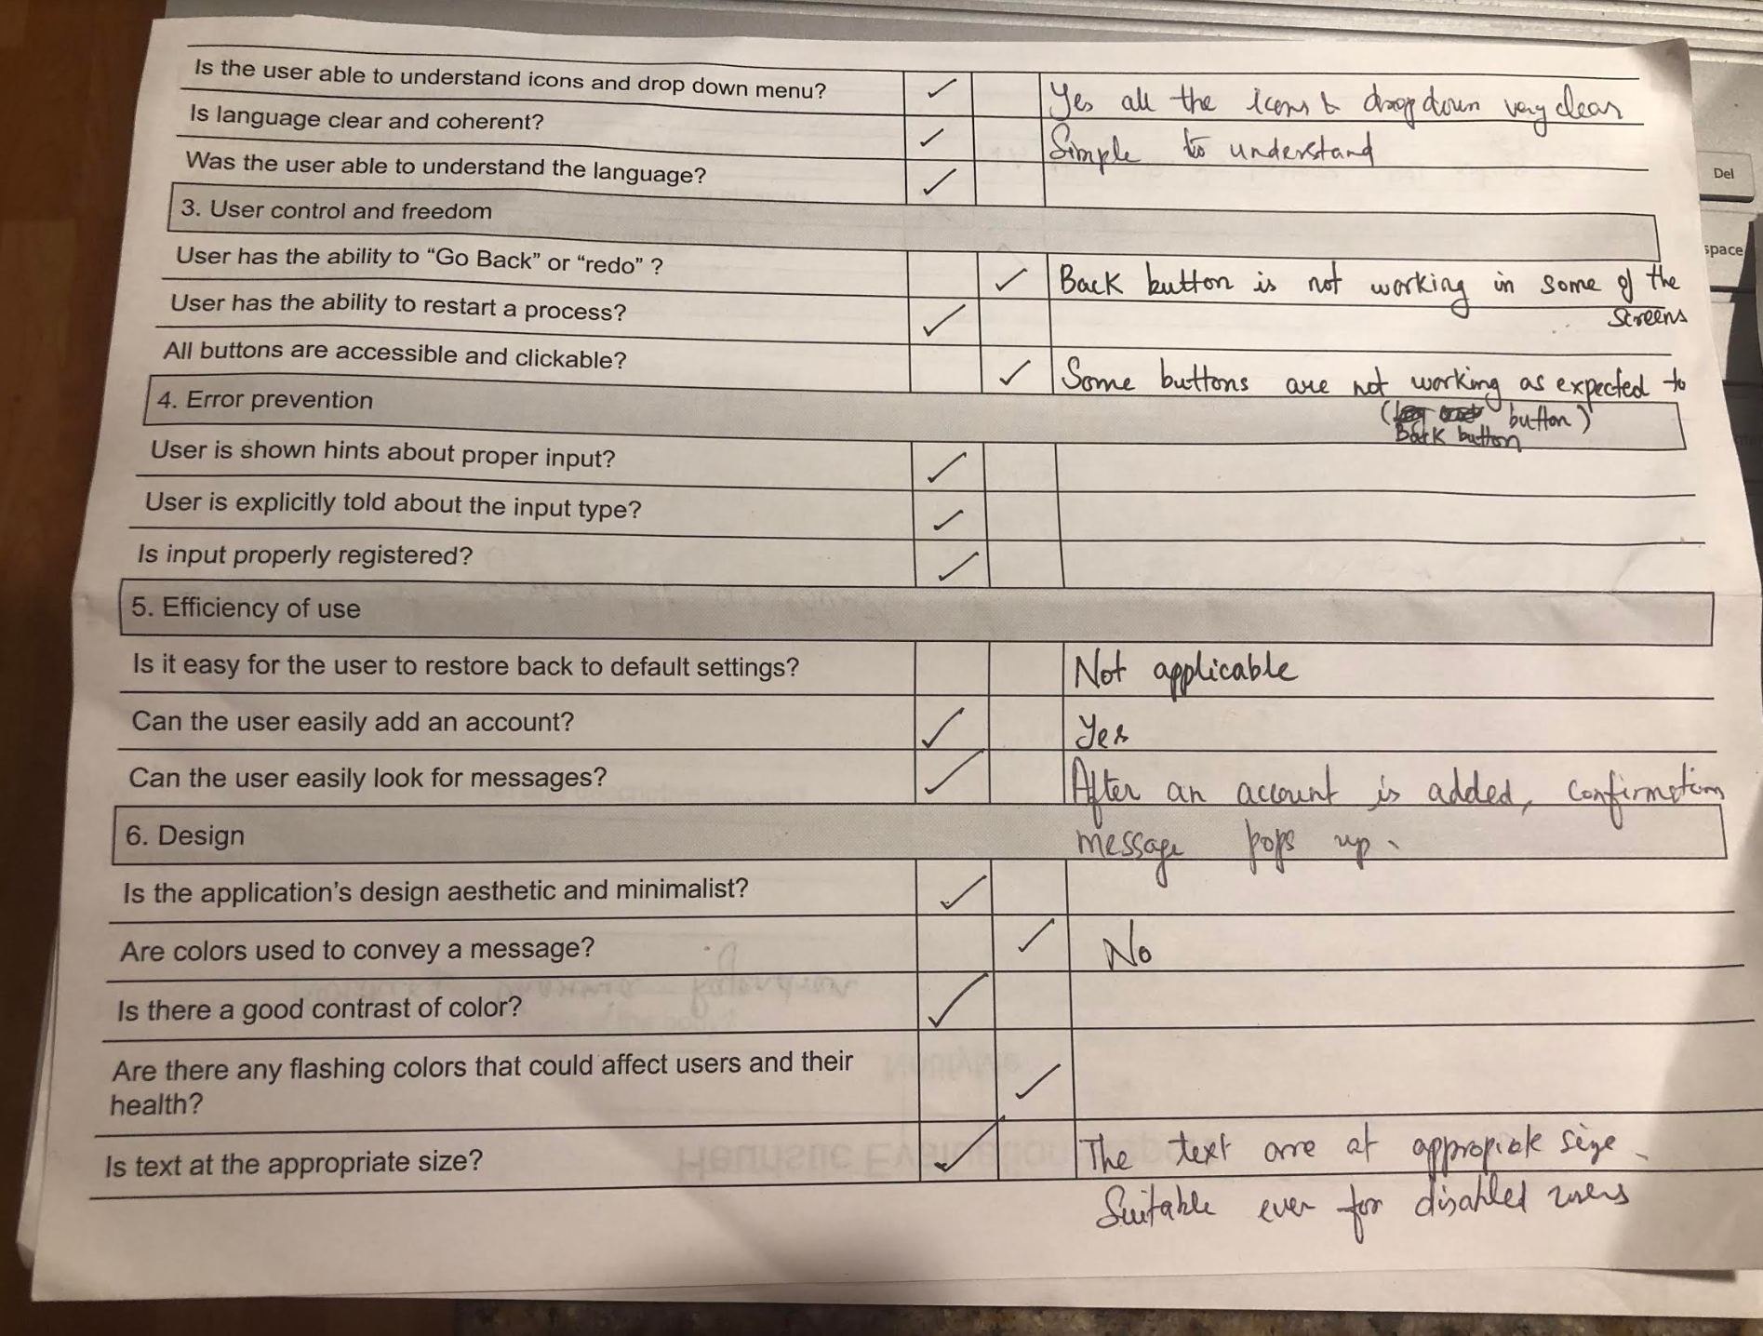

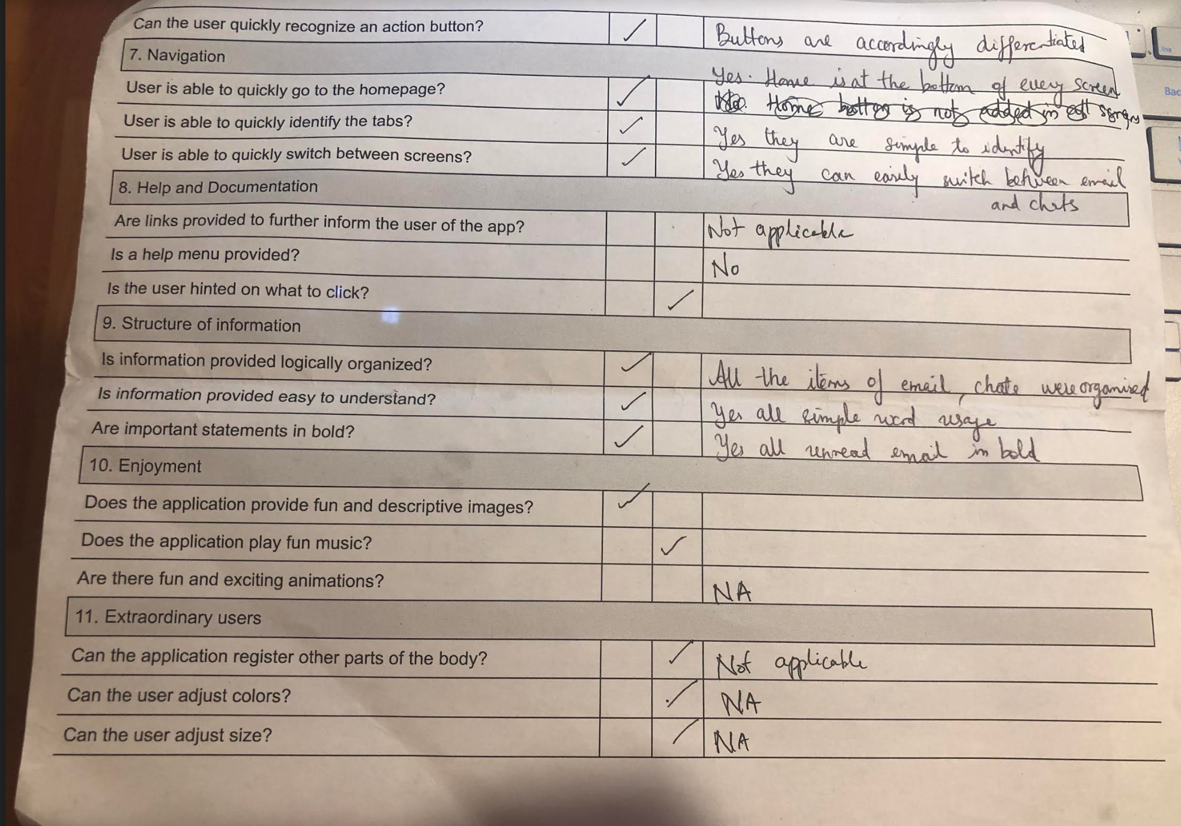

**Julalak’s checklist**

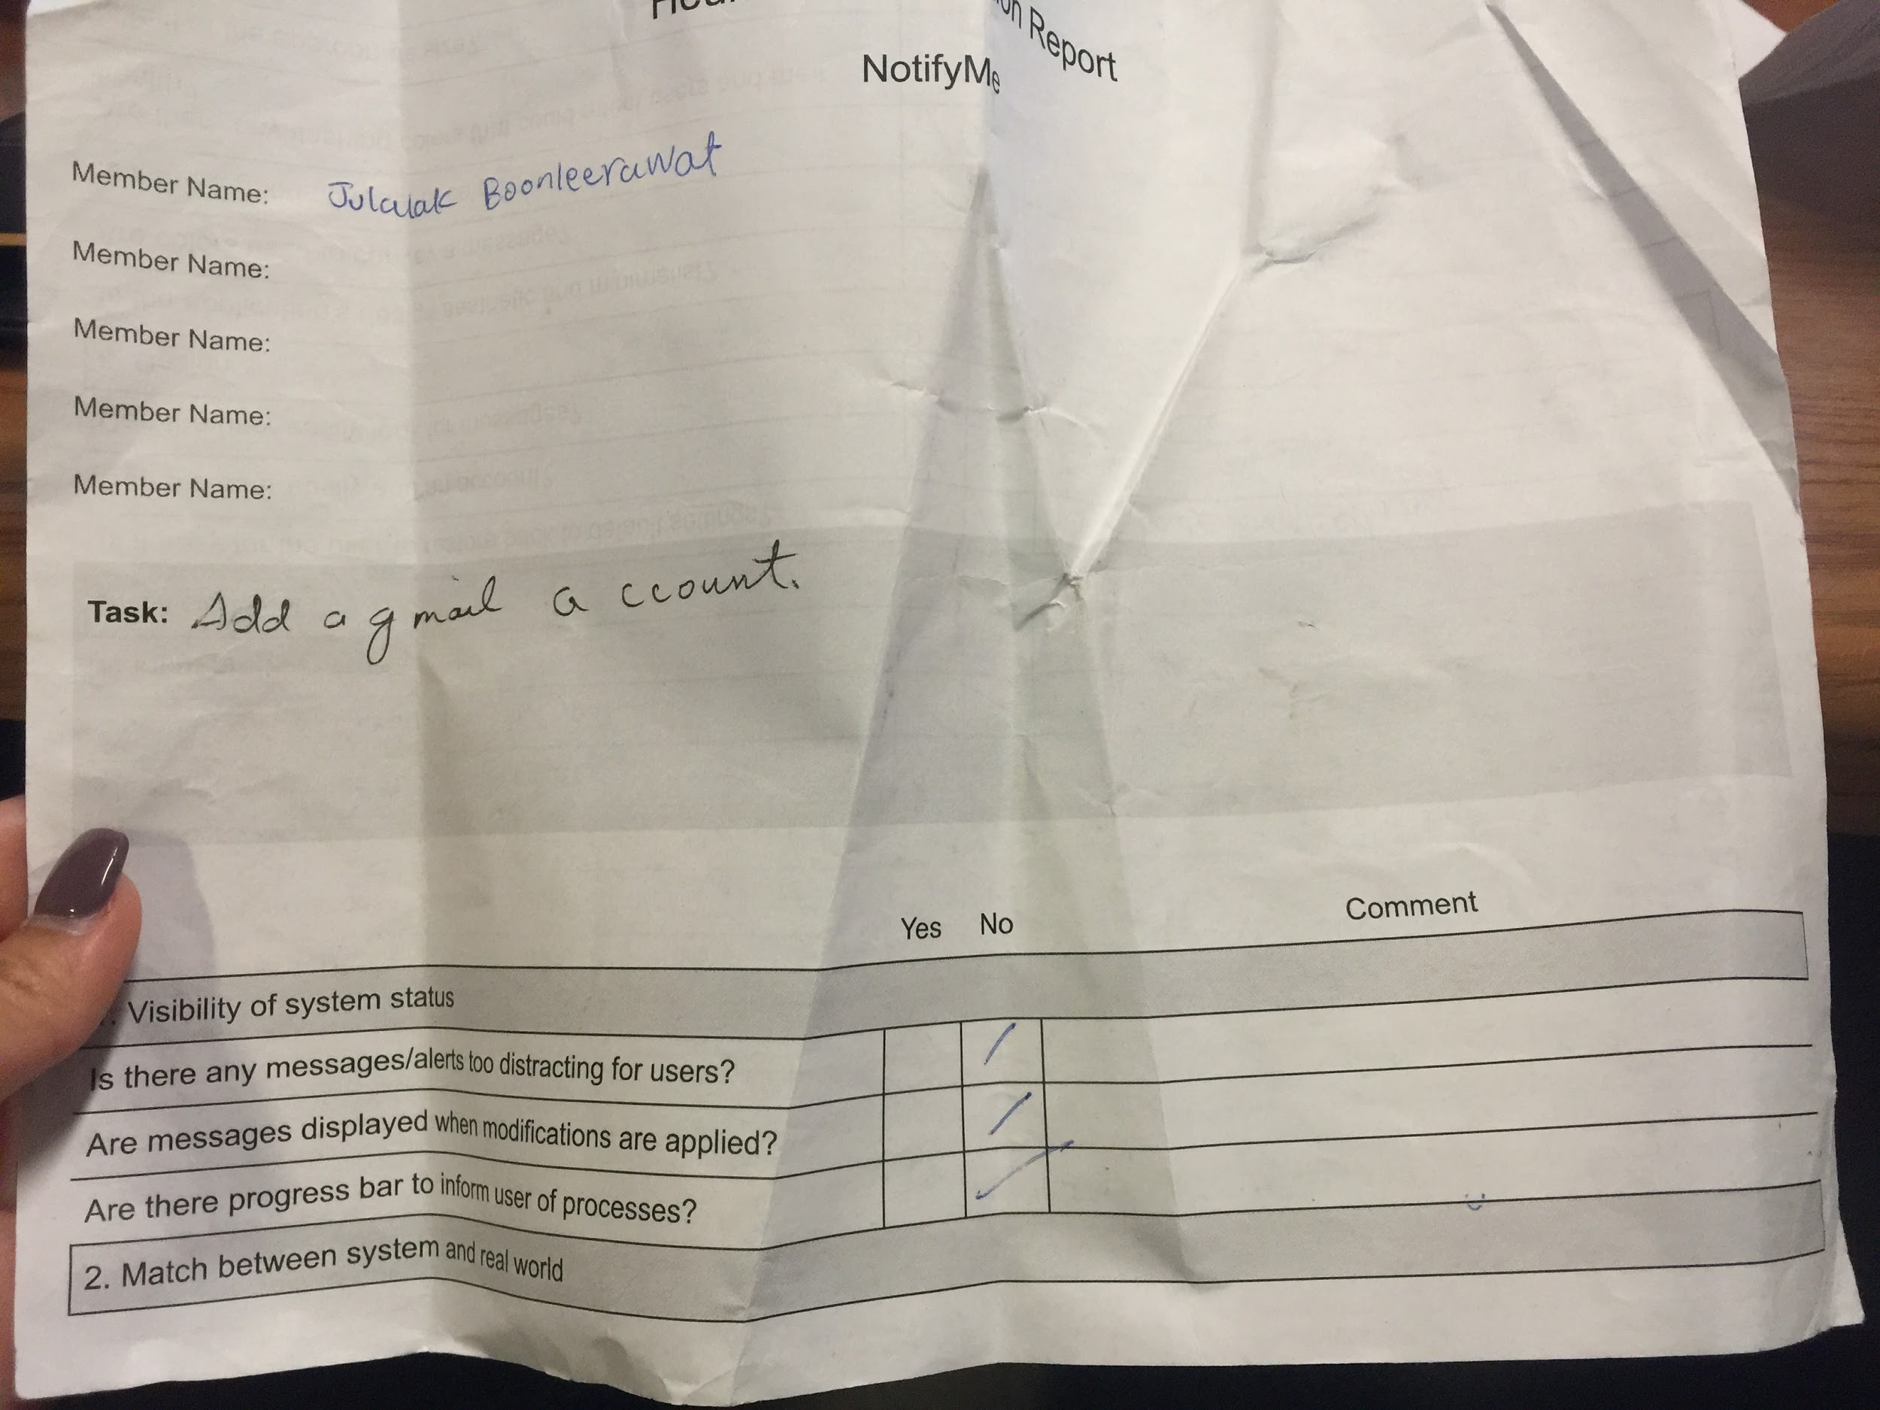

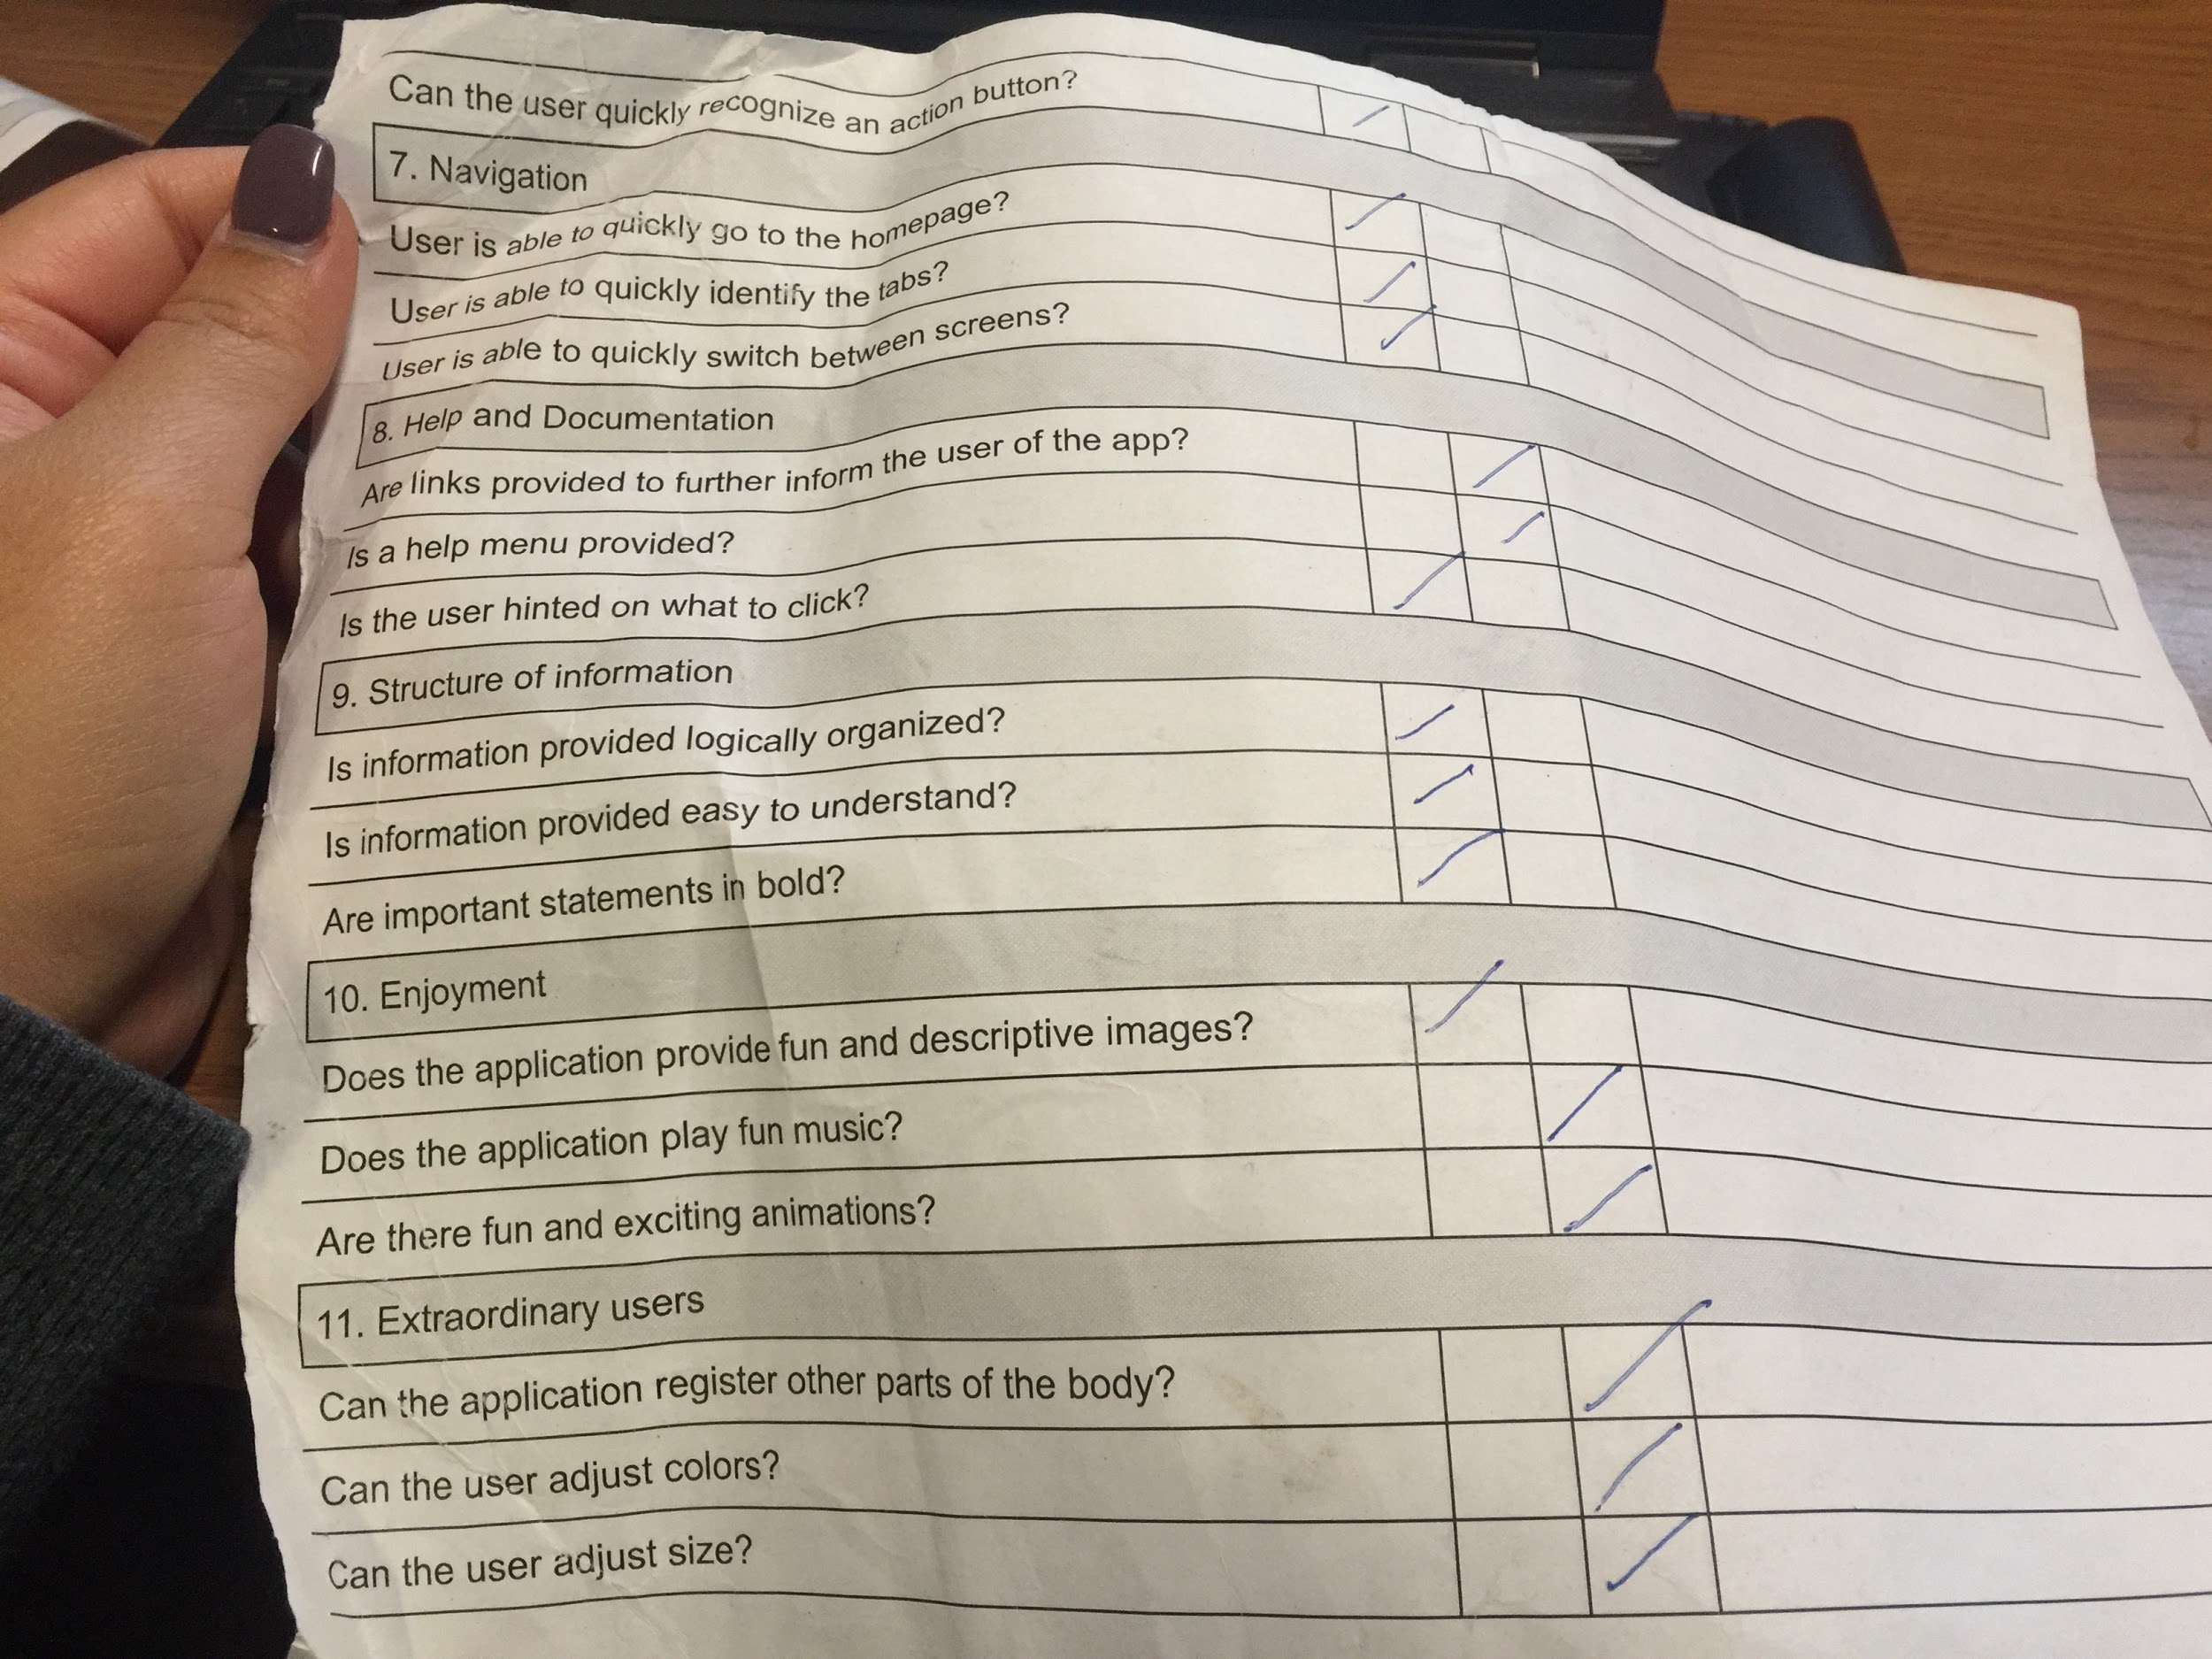

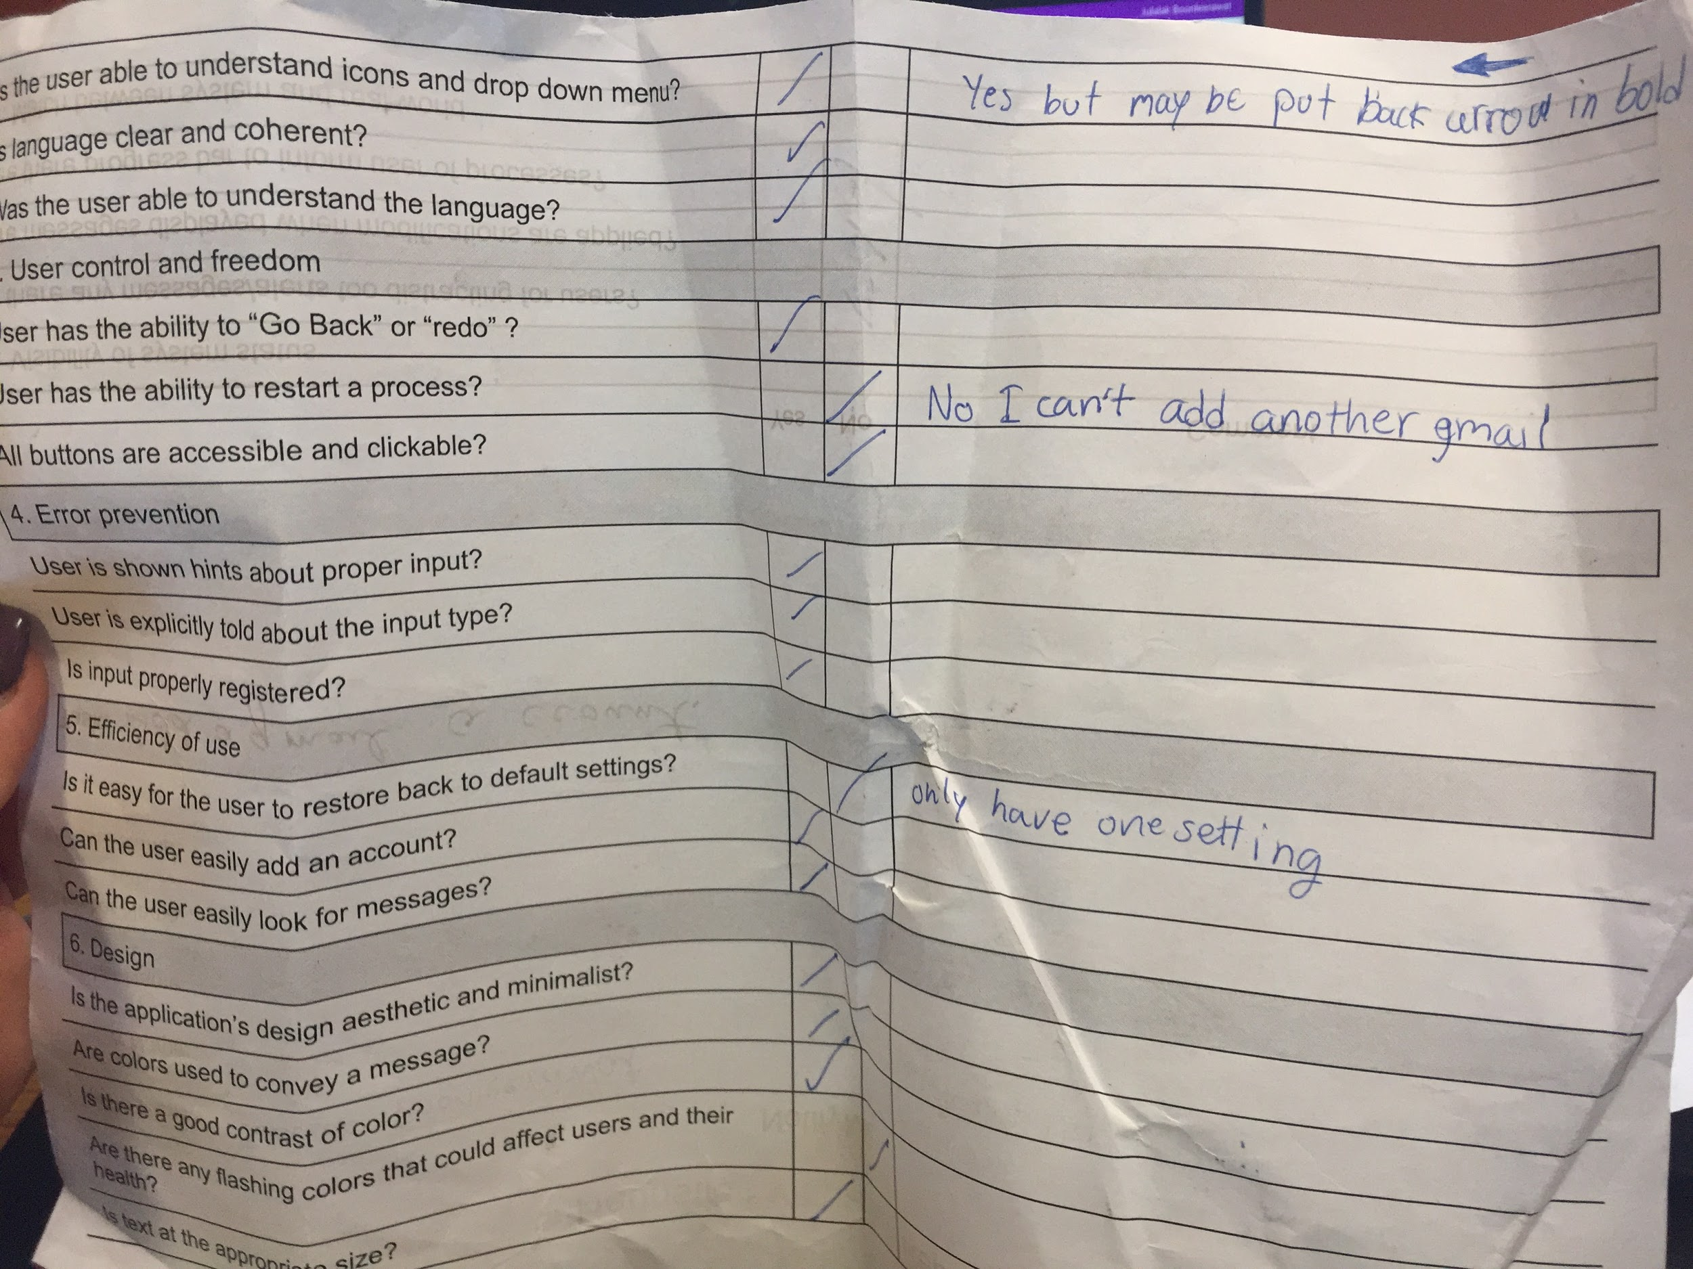

**Debrief:** The application that the accessible boys had developed is quite interesting with interactive design. It helped us to navigate through various options that the user can opt for. The foreground and background colors were up to the standards and did not show any kind of inaccessibility. Contrast is good in terms of color and there are no flashing colors. Confirmation messages pop out when a task is completed, thus providing good feedback to the user. The home button is by default placed at the bottom of the application that can enable the user to go to home from whichever screen he/she is. The application is very minimalistic, thus enabling users of different kind to access the application with ease. The icons and buttons are clear and understandable, thus usage of complex words are being avoided. Text size is large enough to read. Gestalt’s principles of design are applied wherever applicable. For example, the law of similarity was shown when options to enter Gmail or Whatapp were stacked on top of each other. All the important texts are in bold, and all the related messages are grouped together, thus providing good readability for the user. Everything is logically organized and easy to understand. For example, the chat messages and emails have a number next to them giving users the implication that when clicked, the next screen will show those number of messages and emails grouped together in a list. This a very handy add-on. There are no fun and descriptive images, but it’s not needed for this particular app. There is no music in the background or animations. Personally, that may take away from the experience of the app anyway. The app was enjoyable to user overall.

**Actions or recommendations to resolve the problems:** There are some flaws. One, the back button does not work as expected in all the screens. That’s a more technical problem, so that must be fixed. Two, sometimes navigation is inefficient, and it would take more time to navigate through the application than to not use the application. We recommend creating more functions such as a back button and redo button. Three, guidelines/links are not provided for further information regarding the application. This might make the application inaccessible for some users. We recommend implementing a “Help” screen that will guide users out of a state of confusion when using the application.

13: General Documentation

**Project team meetings:**

Week 5 - First meeting. This week we had a project proposal due so we collabed via group text to get the assignment done.

Week 6: This week we worked on individual matrices. We came together to choose the best one, which would also be used as our group matrices.

Week 9: This week was important for us to meet. We had to prepare for the upcoming usability test. We had to create a script for the facilitator and debriefers to use. We also had to divide up work for the creation of the low-fidelity prototype.

Week 11: We met after class to conduct the low-fidelity usability test.

Week 13: We met to prepare for the high-fidelity usability test. We had to develop scripts as well as divide up the work of designing the high-fidelity prototype.

Week 14: We held a meeting to conduct the high-fidelity usability test. This would be our last meeting outside class hours.

**Relevant information from lectures:**

The following slides are taken from lecture powerpoints. They were used quite often when designing our prototype.

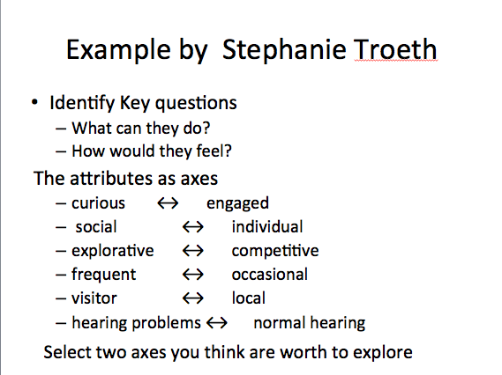

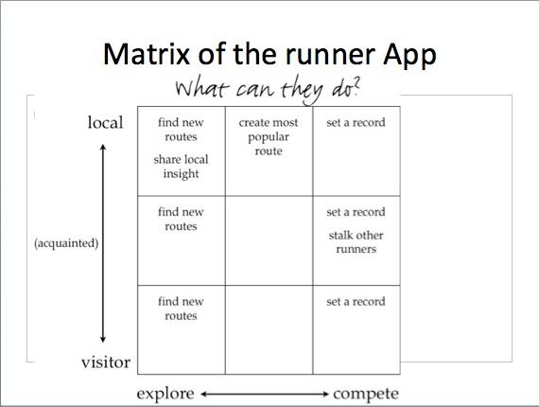

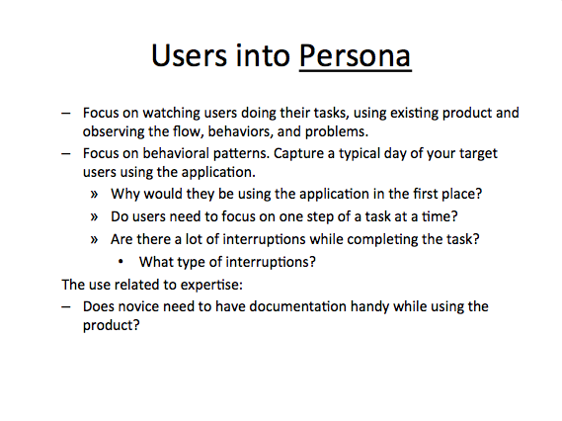

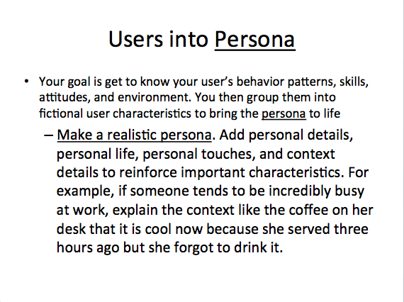

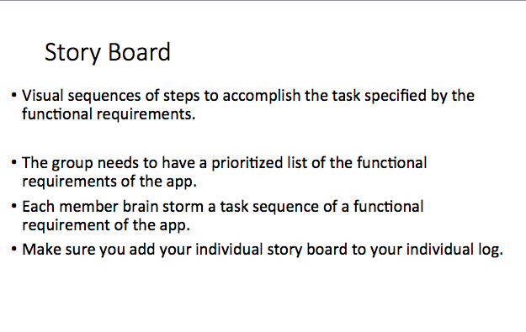

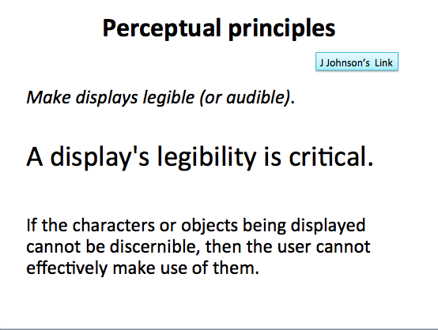

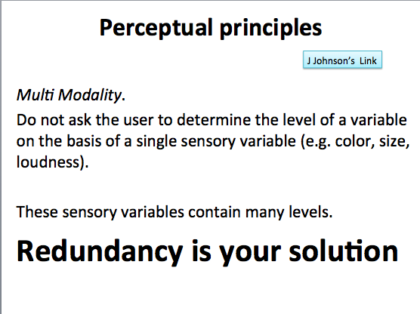

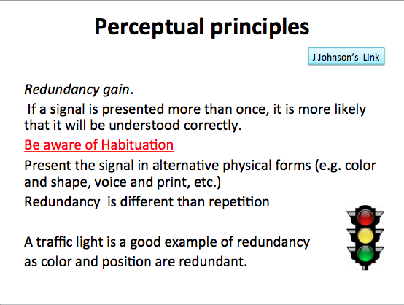

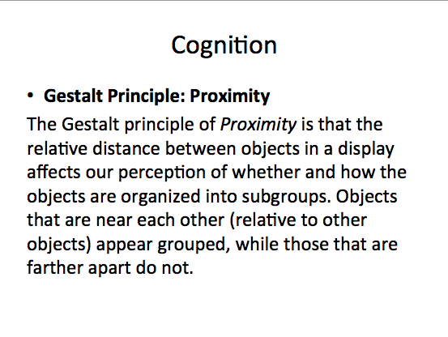

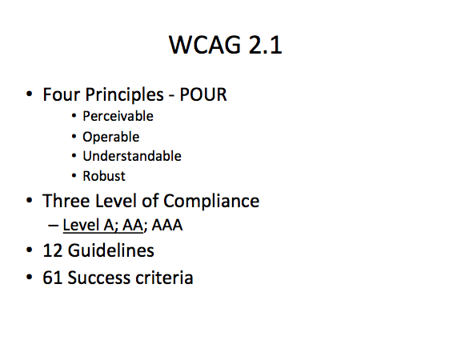

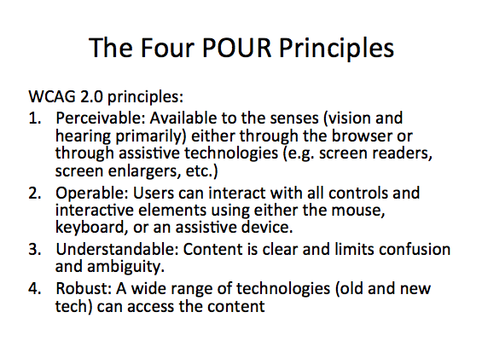

**Contact information:**

Nicholas Yoon (Potential user for low fidelity test)

(562) 396-2911

Muneeba Baluch (User for low fidelity test)

(818) 943-1389

Mary VerPlank (User for high fidelity test)

(323) 702-8975

mary@verplankcreative.com

**Outcomes of conversations:**

Nicholas Yoon was supposed to be our user for the low fidelity test. However, at the last minute, he had to postpone the meeting day. His text message was “I’m so sorry my little one had a fever of 103 this morning at 4am so I won’t be able to come in the morning.” Of course, his son’s health is a priority, so we had to let that slide. He asked to reschedule in the night time. However, some of our group members couldn’t attend. This resulted in us having to find a new user.

Mary VerPlank, a student in our class, agreed to be a user in our test as she is a mother of a young one. That being said, she is also very busy with school, work, and being a mom. So, she gave us an allotted time to meet. We ended up at her CSUN office in Manzanita Hall, room 165.

**Records of outside resources:**

https://www.w3.org/TR/UNDERSTANDING-WCAG20/intro.html#introduction-fourprincs-head

We needed extra help from online. We consulted W3C’s website for more in-depth information on WCAG 2.0. The website is mentioned above. This helped distinguish and understand the four main principles of accessibility. It was with this website that we were able to properly compile informational slides for the presentation.

**Software used:**

No software was used. However, we did utilize a cloud-based design tool called Figma. Here are some reasons why Figma was a good choice for our high-fidelity prototype:

* It works on any operating system that runs a web browser. Macs, Windows PCs, Linux machines, and even Chromebooks can be used with Figma.
* Because Figma is browser-based, teams can collaborate as they would in Google Docs.
* Figma uses Slack as its communication channel. When a Figma channel is created in Slack, any comments or design edits made in Figma are “slacked” to the team.
* Figma also allows permissions-based sharing of any file, page, or frame.
* Figma also shares live embed code snippets to paste an iFrame in third-party tools.
* Figma supports in-app commenting in both design and prototyping modes.
* Figma now has developer APIs to allow true integration with any browser-based app.

14: Conclusion

**Samira:-**

In conclusion, this project has been unlike anything I’ve ever done. I never had to think about users before and I didn’t realize there are so many elements that need to be taken into consideration when designing a website or an application. This project was so lengthy and extensive that I feel this will stay with me in the future. If I ever do front-end development, I will keep the principles and guidelines that we learned in mind. For future projects, I recommend assigning either an individual log or group log document but not both. I believe both make things overwhelming for students.

**Karthika**:

Finally a whole new user application was created by building small blocks such as finding needs, matrices, persona, scenario, storyboard, low fidelity and usability tests. It helped us learn how to analyze an issue from user perspective and develop a product considering user perception in all phases of development. The project is a good learning and testing it directly with the user in real time was a new experience for me.

**Julie** :

The project was a new experience I got from the entire process of creating user oriented application. Each team member participated in the process with the same goal which is to design the application that properly serve the target users. I have learned from planning, exchanging thoughts, collaborations as united team and listen to the voice of users. This project gave me many valuable lesson. I still have a lot to learn in my long professional journey, but this project has inspired me to become a better professional who actually pay attention to what users want.

**Kevin**:

It’s important to have the goals and tasks decided on before the prototype tests, so the usability tests can be more streamlined because the test is very limited. It’s more important to find how you fail your own tests than what you succeeded in.